Table of Contents

CHAPTER 1 – STRUCTURE AND FUNCTION: how the architecture of the lung subserves its function 1

CHAPTER 2 – VENTILATION how gas gets to the alveoli 6

CHAPTER 3 - DIFFUSION how gas gets across the blood-gas barrier 10

CHAPTER 4 – BLOOD FLOW AND METABOLISM how the pulmonary circulation removes gas from the lung and alters some metabolites 16

CHAPTER 5 – VENTILATION-PERFUSION RELATIONSHIP how matching of gas and blood determines gas exchange 26

CHAPTER 6 – GAS TRANSPORT BY THE BLOOD: how gases are moved to and from the peripheral tissues 36

CHAPTER 7 – MECHANICS OF BREATHING: how the lung is supported and moved 48

CHAPTER 8 – CONTROL OF VENTILATION: how gas exchange is regulated 59

Respiratory Gas Transport 68

VSL[14] Questions 69

Terminology 72

Difference between Bohr And Haldane Effect 73

# CHAPTER 1 – STRUCTURE AND FUNCTION: how the architecture of the lung subserves its function

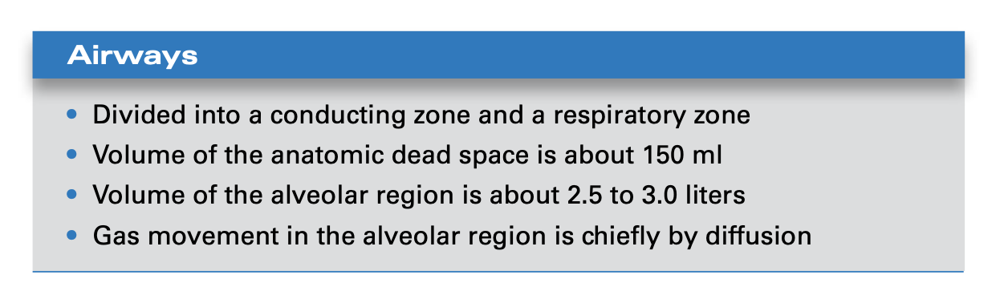

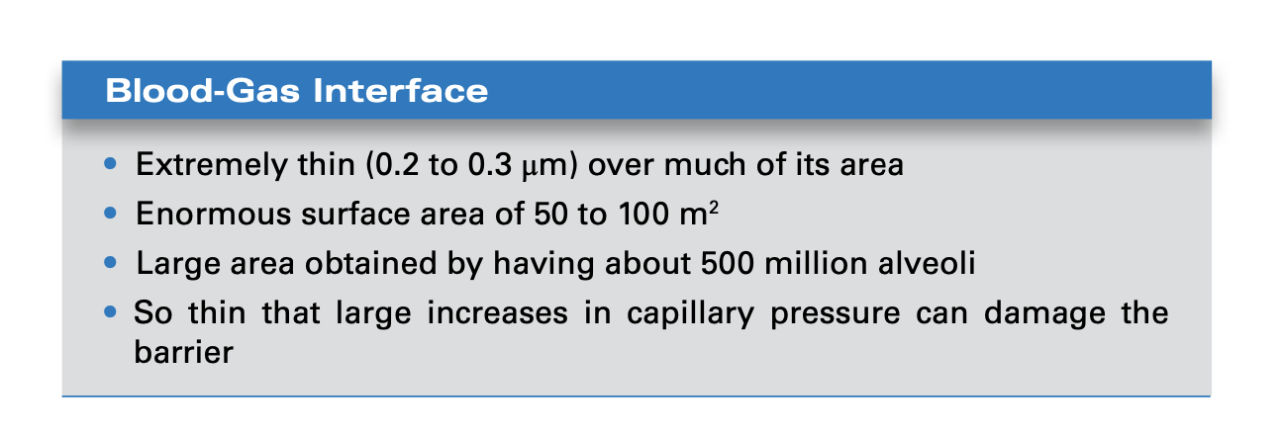

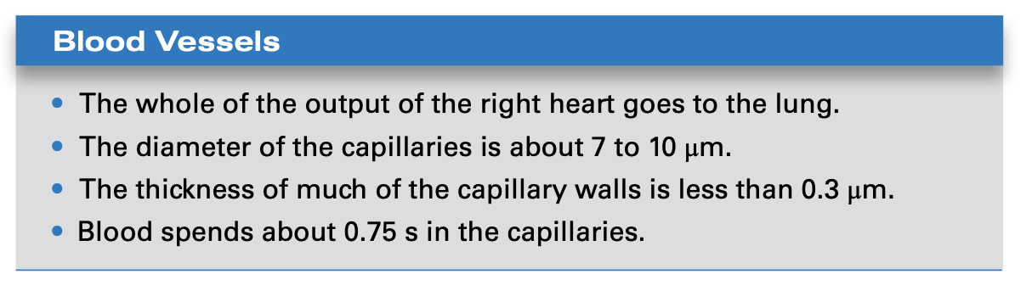

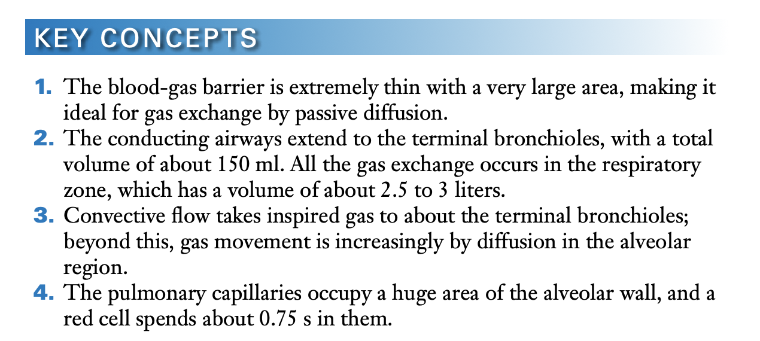

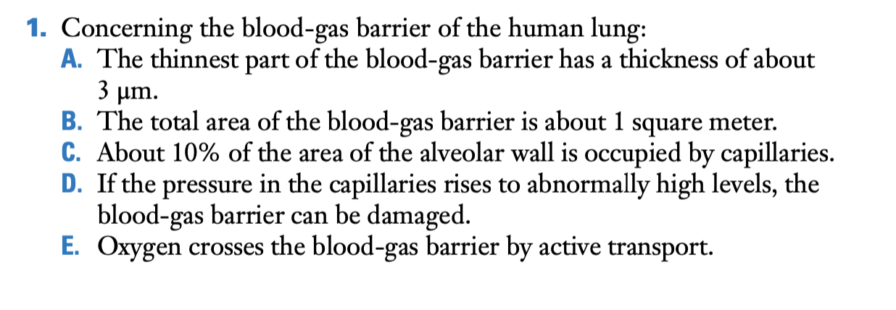

D

The capillary walls are so thin that if the pressure in them rises too much, they are damaged and leak plasma or blood, a condition known as stress failure. The other choices are incorrect because the thinnest part of the blood-gas barrier is about 0.3 μm thick, its total area exceeds 50 square meters, almost all of the area of the alveolar wall is occupied by capillaries, and oxygen crosses the barrier by passive diffusion

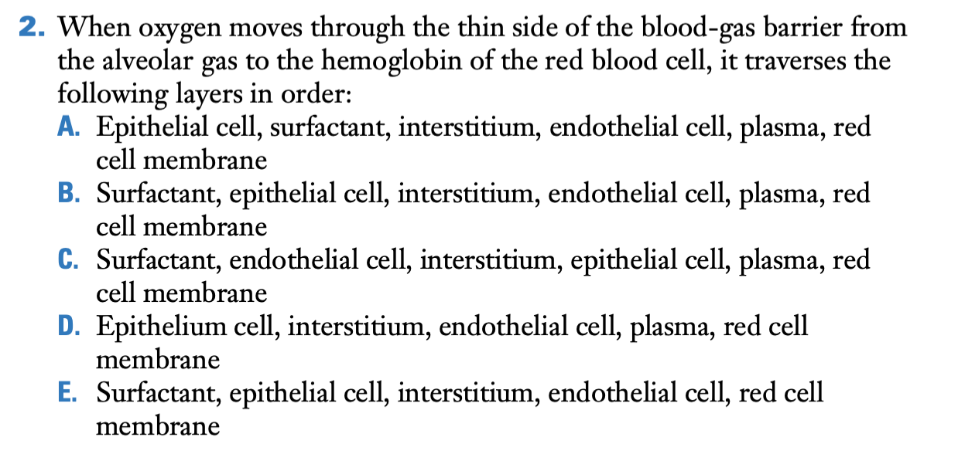

B

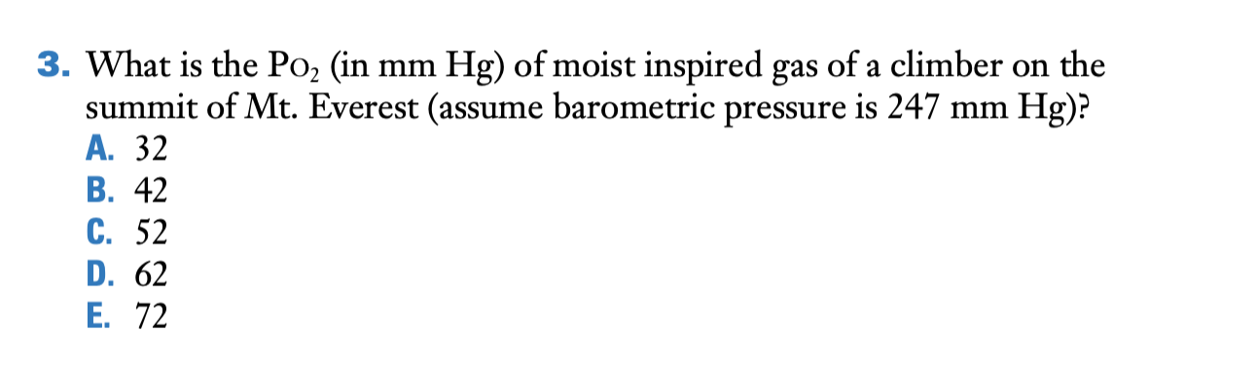

B.

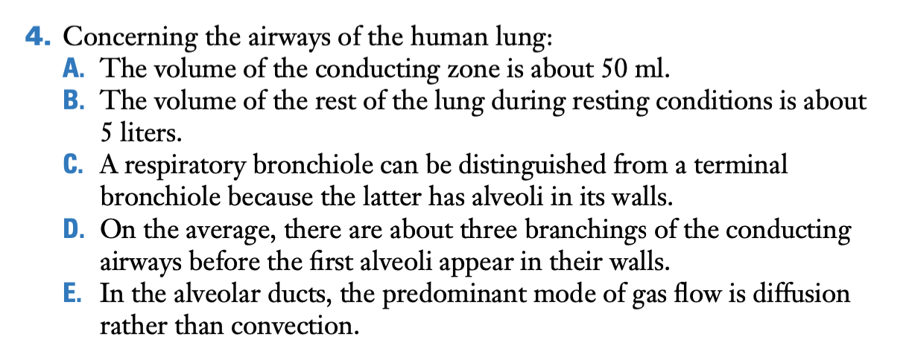

E is correct. The combined cross-sectional area of the alveolar ducts is so great (Figure 1.5) that gas diffusion is the main mode of transport rather than convection. The other choices are incorrect. The volume of the conducting airways is about 150 ml, the volume of the lung at FRC is about 3 liters, a respiratory bronchiole but not a terminal bronchiole has alveoli in its walls, and there are about 16 branches of the conducting airways before the first alveoli appear.

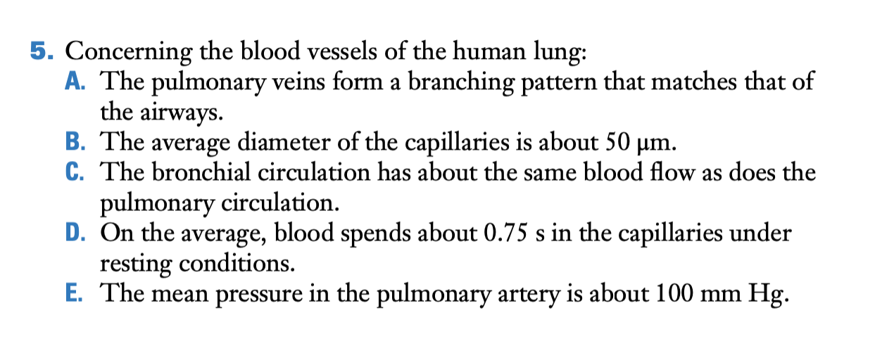

D. The other choices are incorrect because the branching pattern of the arteries, not the veins, matches the airways; the average diameter of the capillaries is about 7 to 10 μm; the flow in the bronchial circulation is very small compared to the pulmonary circulation; and the mean pressure in the pulmonary artery is about 15 mm Hg.

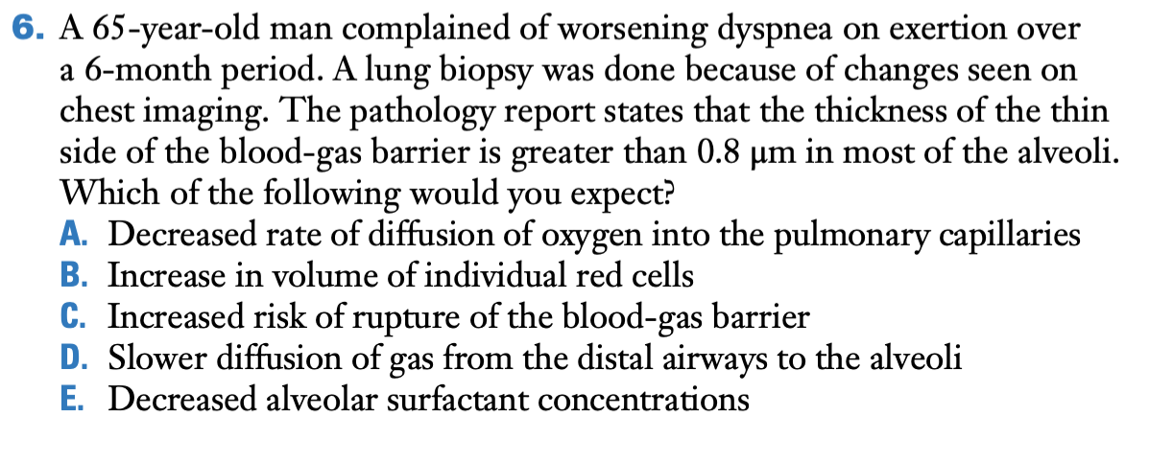

A is correct. The thin side of the blood-gas barrier is 0.8 μm, which is much thicker than normal. This will slow the rate of diffusion of oxygen across the barrier but will not affect the volume of individual red cells, diffusion of gas in the distal airways, or alveolar surfactant concentrations. The risk of rupture of the blood-gas barrier should not be increased. In fact, if the thickening is caused by deposition of collagen, the risk of rupture might be reduced.

# CHAPTER 2 – VENTILATION how gas gets to the alveoli

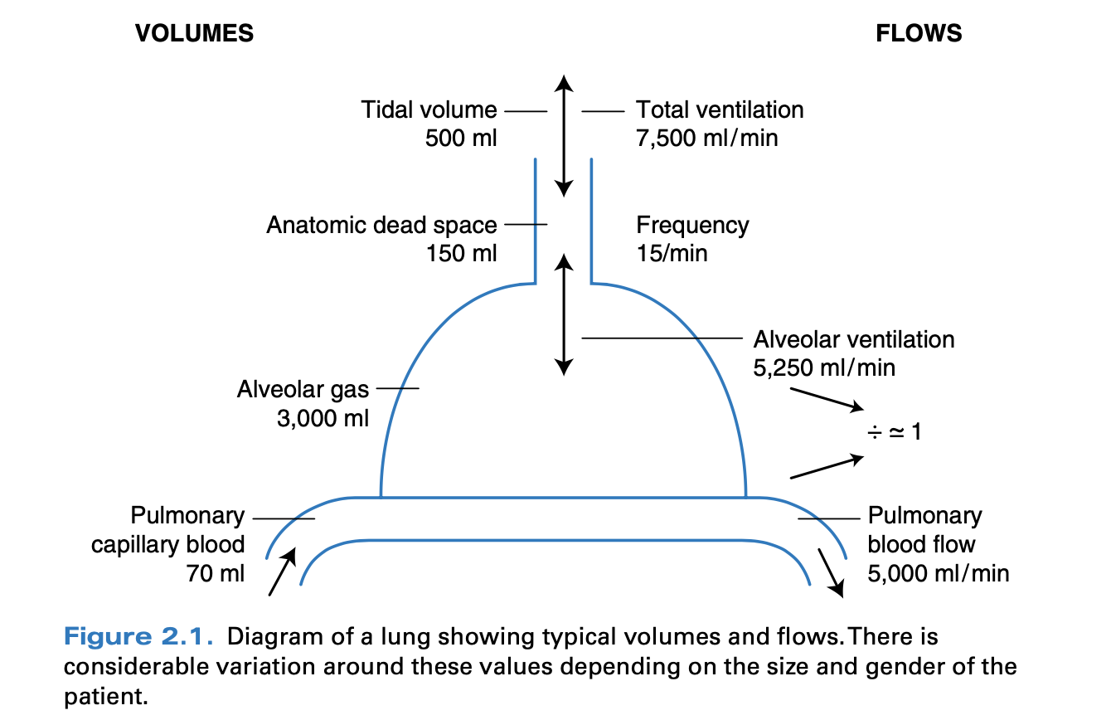

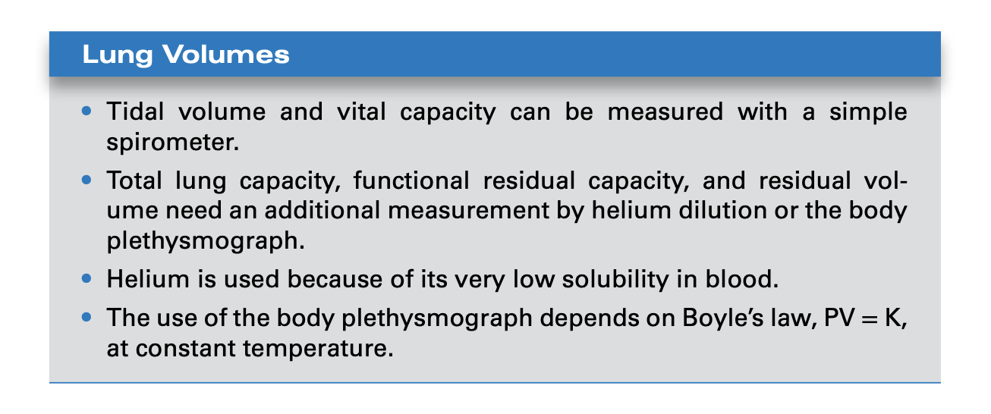

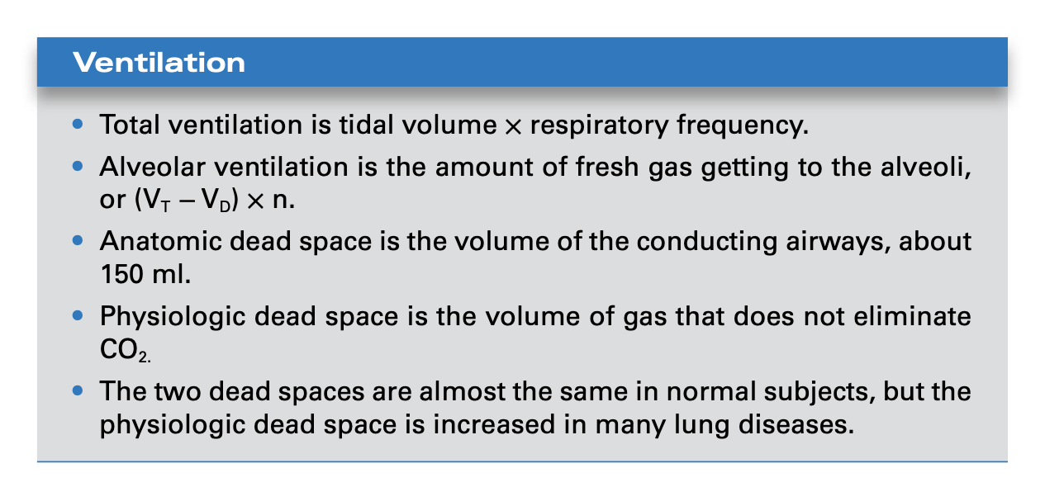

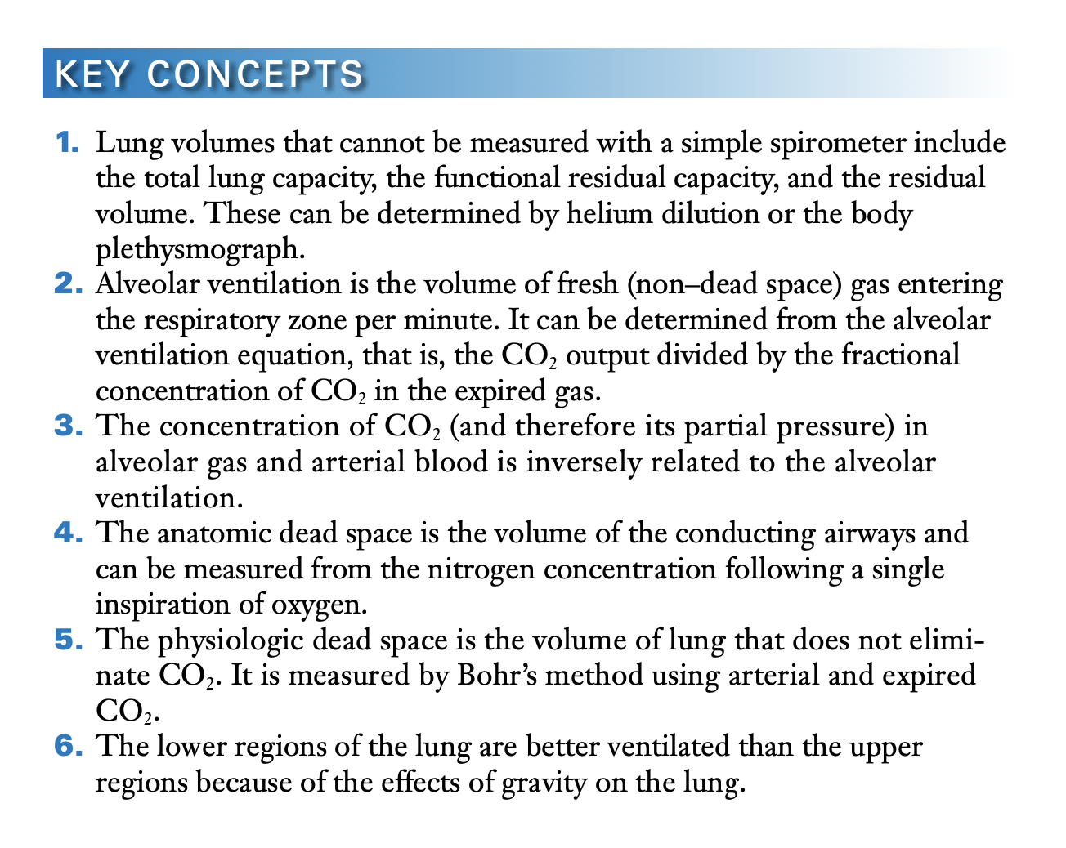

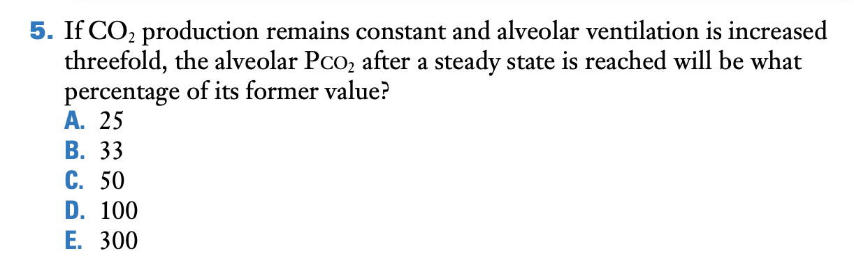

B.

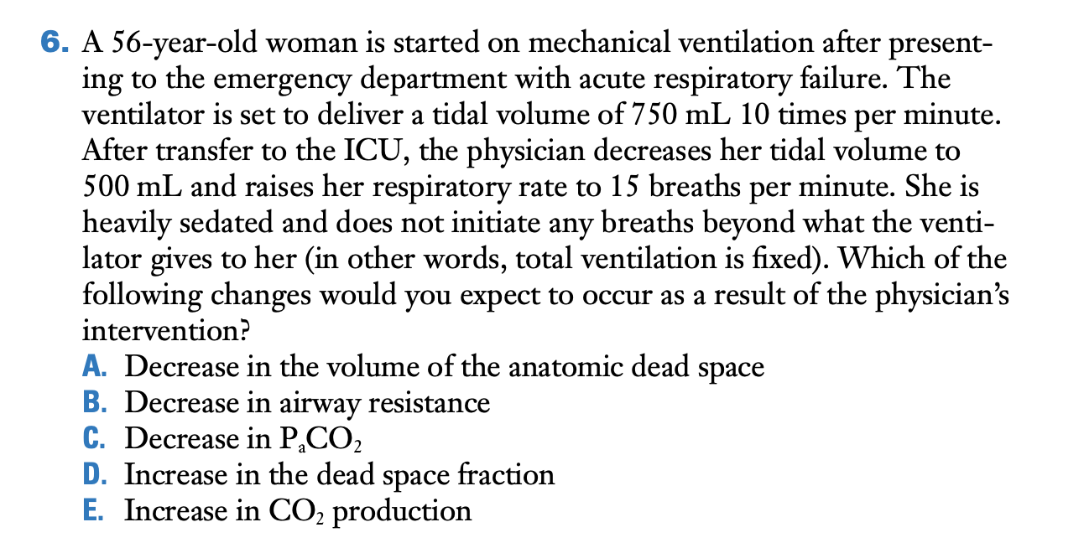

D. Dead space fraction

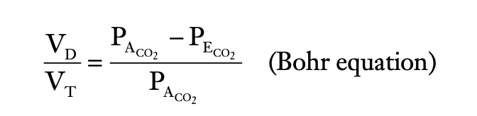

where A and E refer to alveolar and mixed expired, respectively (see Appendix A). The normal ratio of dead space to tidal volume is in the range of 0.2 to 0.35 during resting breathing. In normal subjects, the PCO2 in alveolar gas and that in arterial blood are virtually identical so that the equation is therefore often written

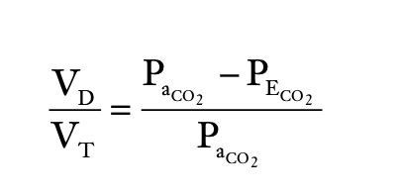

PaCo2: arterial pressure of CO2

Any changes in intrapulmonary shunting, ventilation/perfusion ratio, or CO2 solubility (Haldane effect) can affect the pulmonary dead space.

D is correct. Because the volume of the anatomic dead space remains largely the same with the change in ventilator settings while the respiratory rate is increased, dead space ventilation is increased. Because minute ventilation is unchanged, the dead space fraction of the total ventilation is increased. The other choices are incorrect. Arterial PO2 would actually increase, while CO2 production and airway resistance would not change.

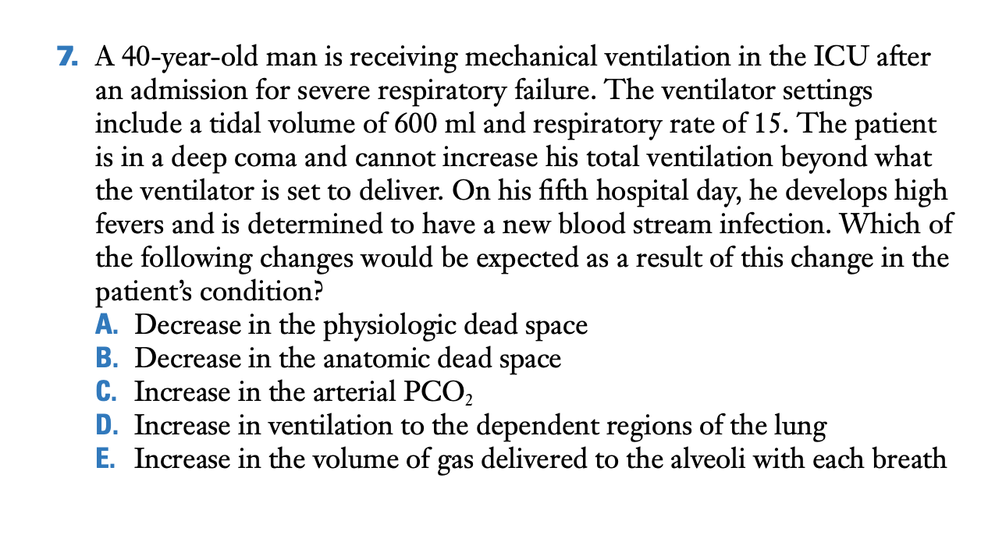

C. Arterial PCO2 is related to the ratio of CO2 production and alveolar ventilation. With fever and a bloodstream infection, CO2 production increases. Because minute ventilation is fixed, the patient cannot raise alveolar ventilation to compensate for the increase in CO2 production and, as a result, arterial PCO2 increases.

# CHAPTER 3 - DIFFUSION how gas gets across the blood-gas barrier

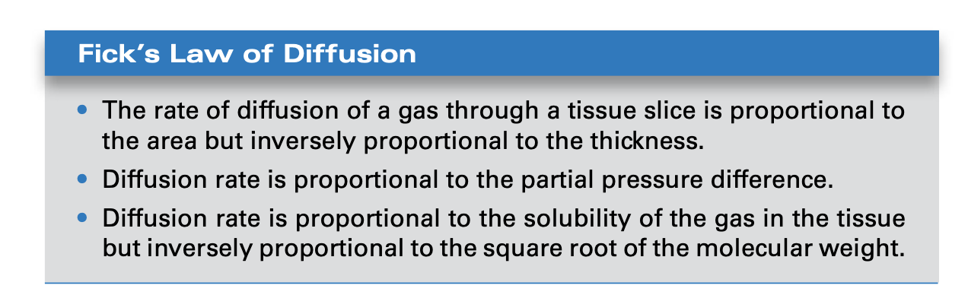

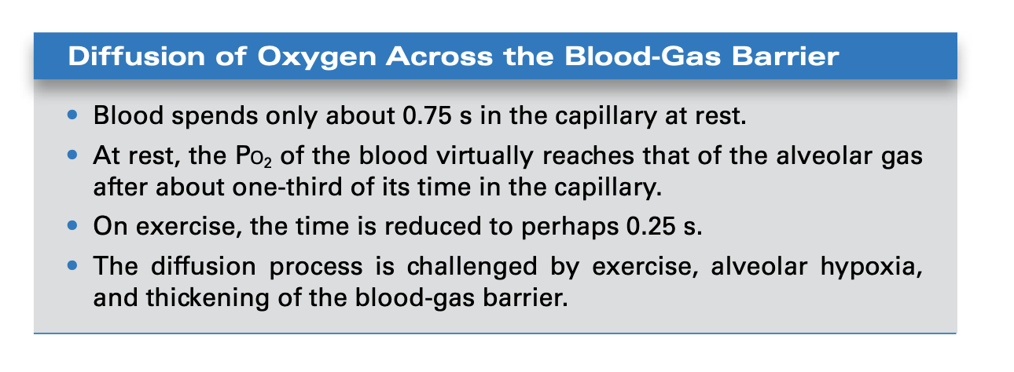

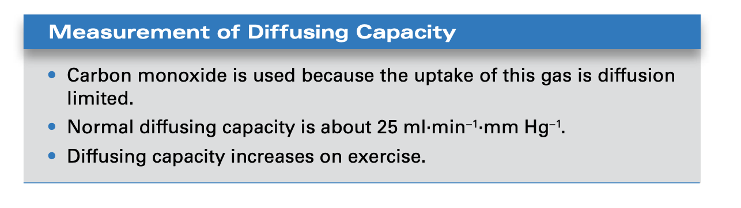

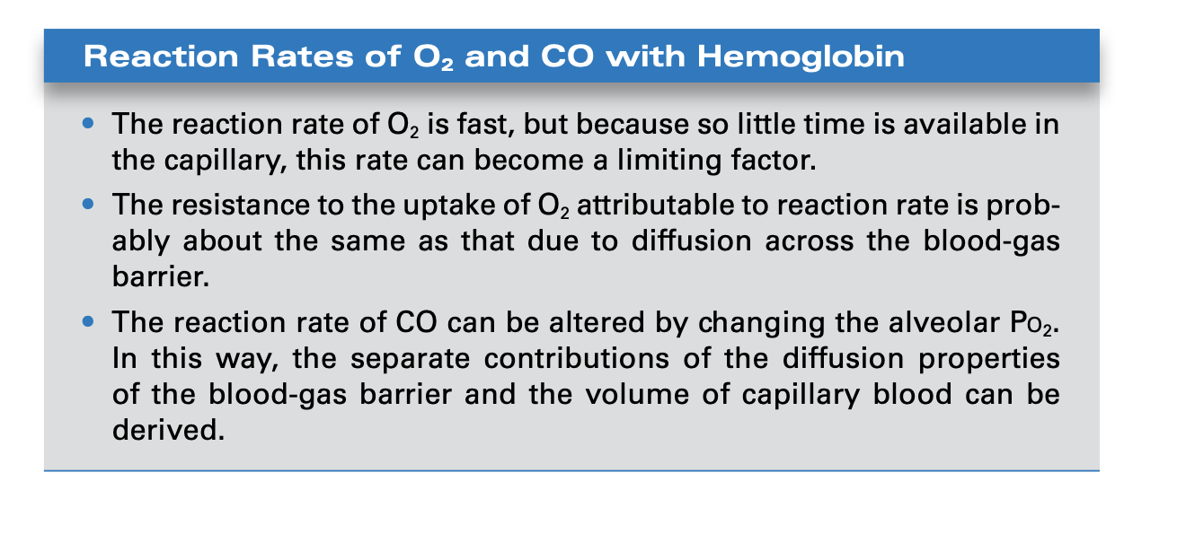

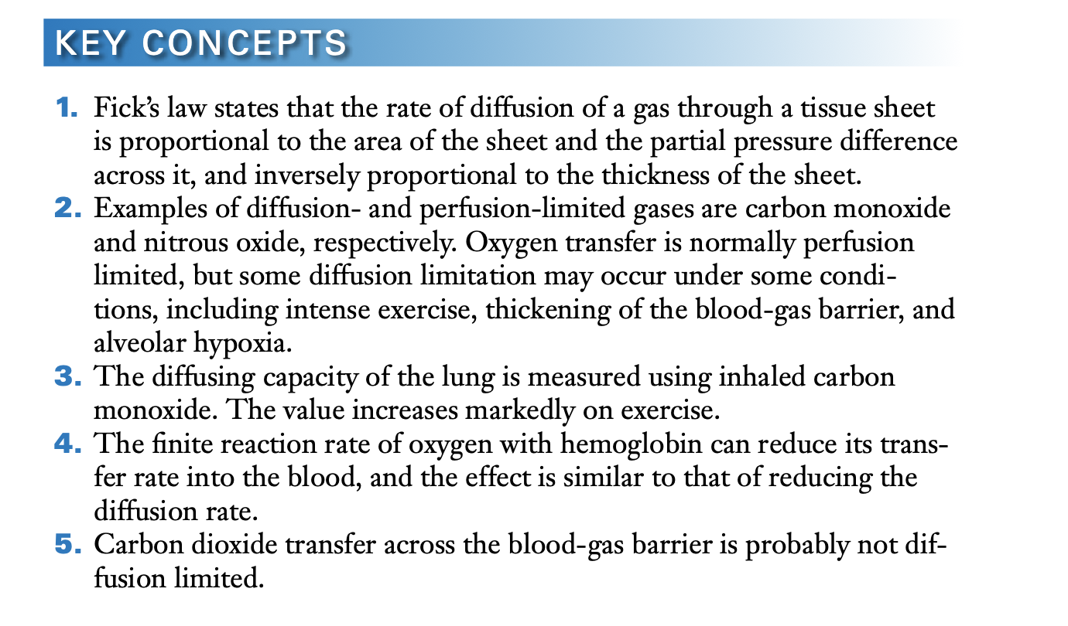

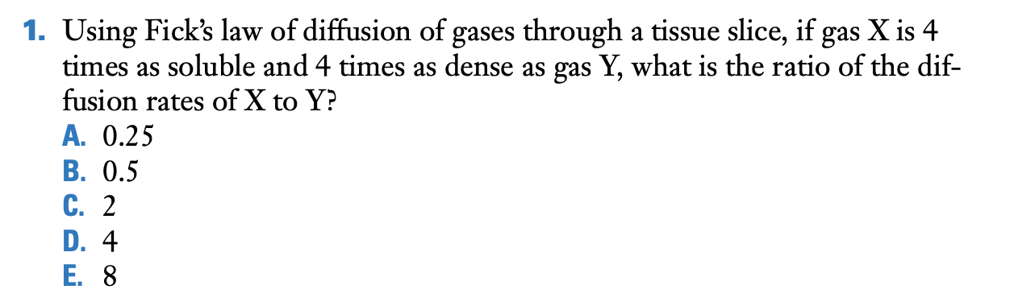

C.

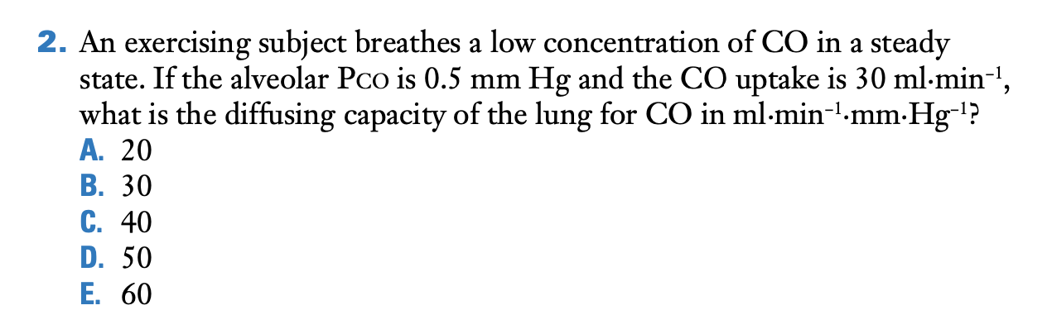

E.

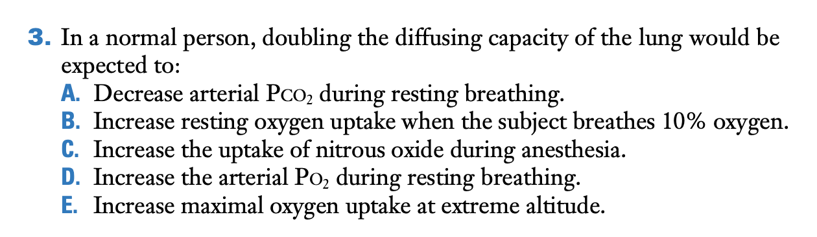

E.

The question is really asking for the conditions under which oxygen uptake or CO2 output are diffusion limited. The only correct answer is maximal oxygen uptake at extreme altitude (see Figure 3.3B). None of the other choices refer to situations where gas transfer is diffusion limited. The only possible alternative choice is B, but resting oxygen uptake is unlikely to be diffusion limited when a subject breathes 10% oxygen.

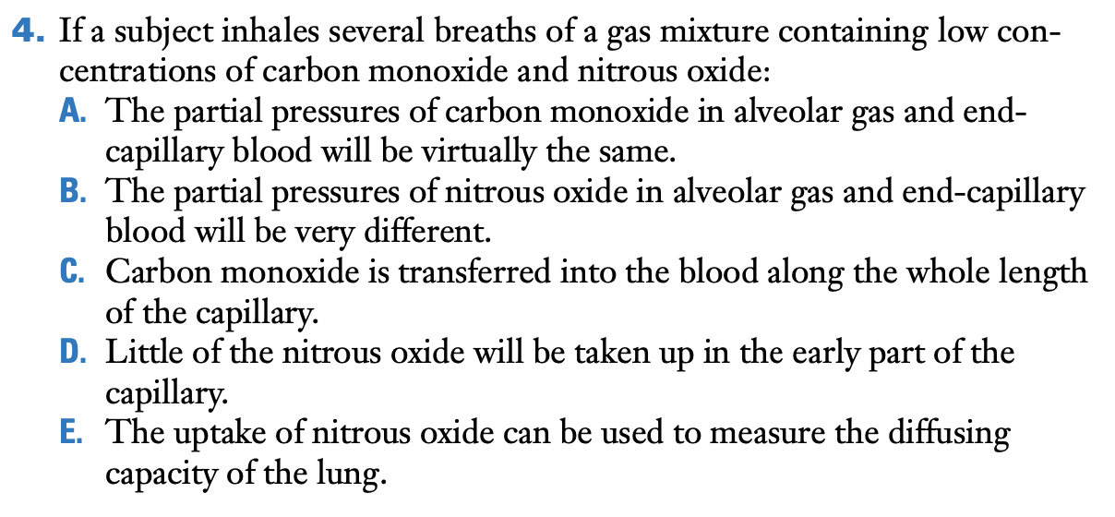

C.

This question is testing the concepts of diffusion and perfusion limitation. Carbon monoxide is a diffusion-limited gas, so it is transferred into the blood along the whole length of the capillary, and there is a large difference in partial pressure between alveolar gas and end-capillary blood (Figure 3.2). The opposite is true for nitrous oxide.

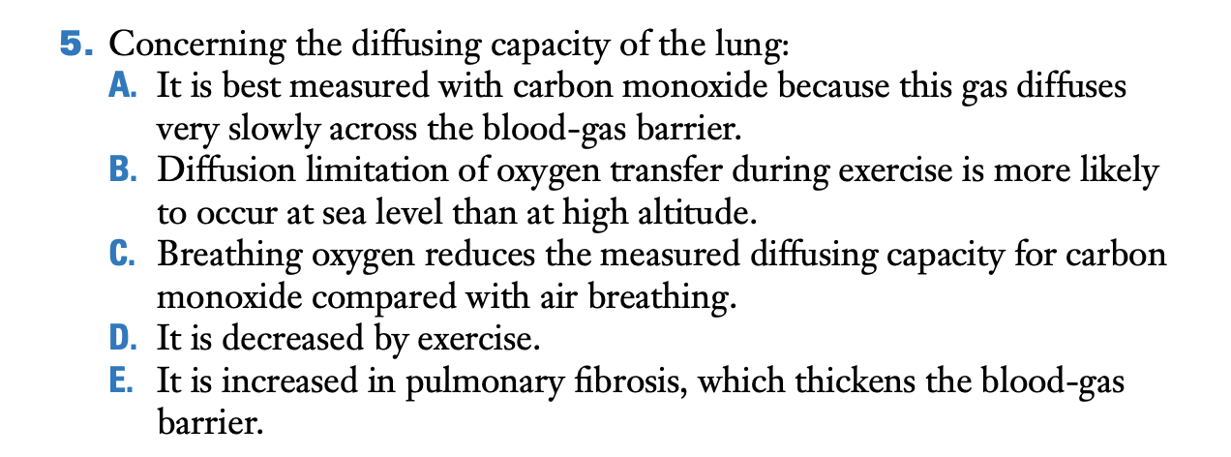

C.

Breathing oxygen reduces the measured diffusing capacity for carbon monoxide because the oxygen competes with carbon monoxide for hemoglobin, and therefore, the rate of reaction of carbon monoxide with hemoglobin (θ) is reduced. The other choices are incorrect because the reason for using carbon monoxide to measure the diffusing capacity of the lung is because it is a diffusion-limited gas, not because it diffuses slowly across the blood-gas barrier (its diffusion rate is not very different from that of oxygen). Diffusion limitation of oxygen transfer during exercise is more likely to occur at high altitude than sea level, and the diffusing capacity is increased by exercise and decreased by pulmonary fibrosis.

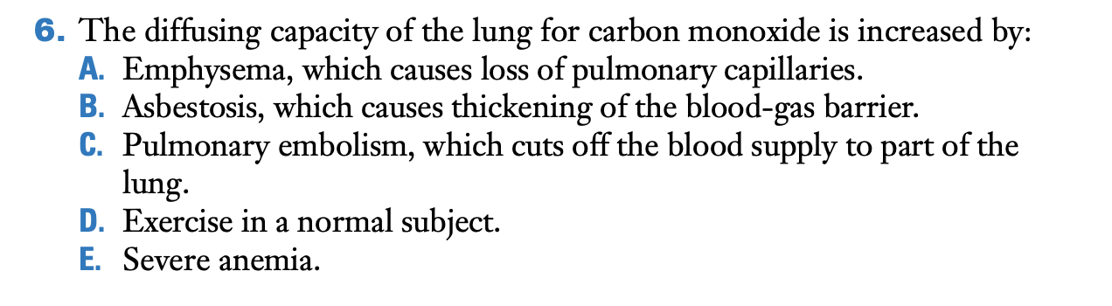

D.

Exercise increases the diffusing capacity because of recruitment and distension of pulmonary capillaries. Emphysema, asbestosis, pulmonary embolism, and severe anemia reduce the diffusing capacity because of a reduction in surface area of the blood-gas barrier, an increase in its thickness, or a reduction of the volume of blood in the pulmonary capillaries.

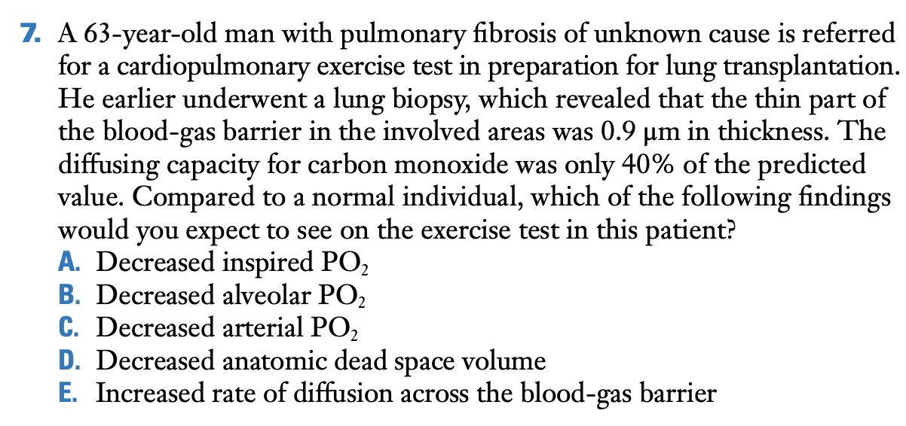

C.

The decreased diffusion capacity for carbon monoxide is consistent with the lung biopsy showing that the blood-gas barrier is thickened. This will slow the rate of diffusion of oxygen across the blood-gas barrier. At rest, the red blood cells spend enough time in the pulmonary capillaries to allow complete equilibration between the alveolar and end-capillary PO2, but with exercise red blood cell transit time will decrease to the point that full equilibration may not occur and the end-capillary PO2 will be lower than the alveolar value. The other choices are incorrect. The inspired PO2 does not change with exercise, while the alveolar PO2 remains largely constant through most of exercise before increasing at the end of the test in most individuals. Anatomic dead space may actually increase slightly when the individual breaths at higher volumes during exercise.

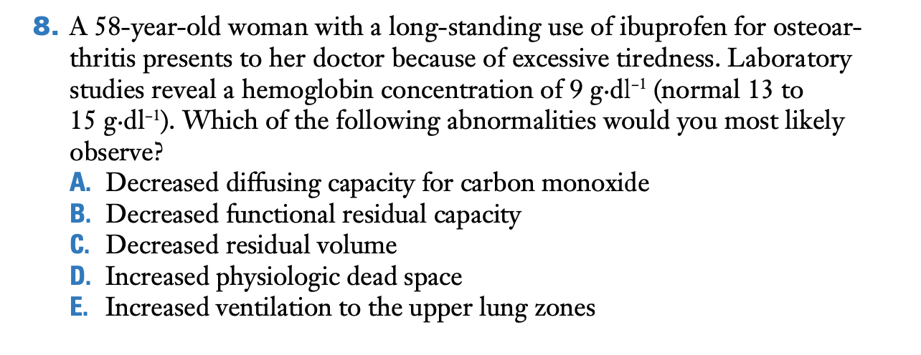

A

The diffusing capacity for carbon monoxide depends on  
the volume of blood in the pulmonary capillaries, or more strictly by  
the volume of red cells containing hemoglobin. Since this is reduced in severe anemia, diffusing capacity is decreased. This is the reason why the diffusing capacity is corrected for hemoglobin concentration.

# CHAPTER 4 – BLOOD FLOW AND METABOLISM how the pulmonary circulation removes gas from the lung and alters some metabolites

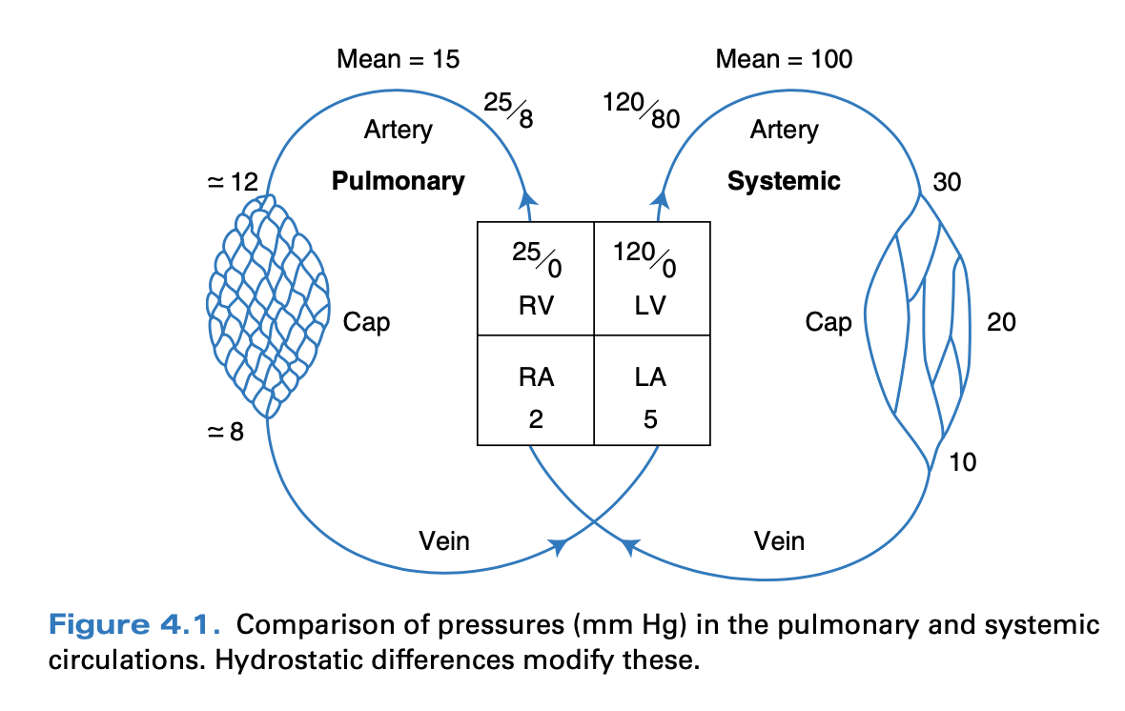

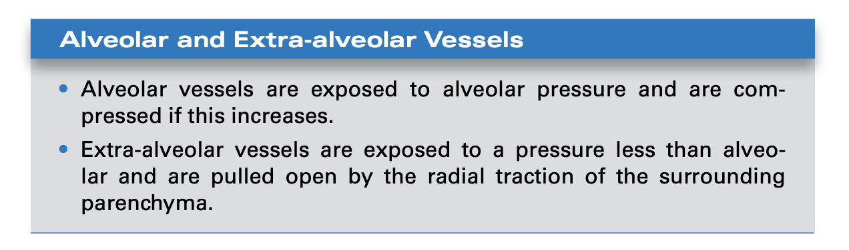

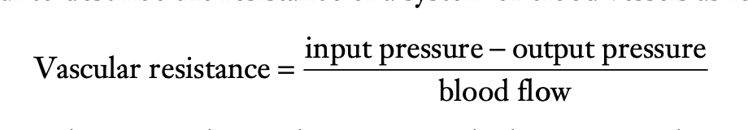

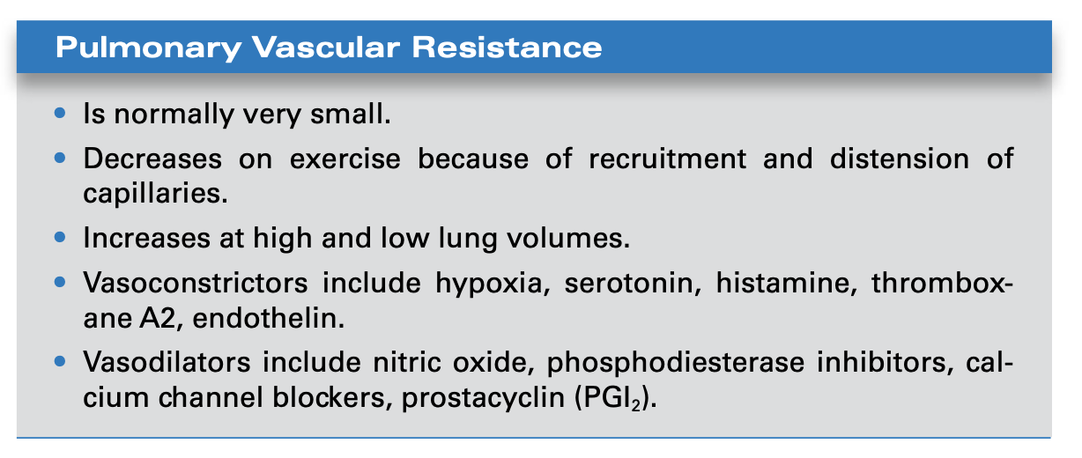

Fick principle:

Volume of blood passing through the lung per min: Q, VO2: O2 consumption per minute, the O2 concentration in the blood entering the lungs is CVO2 and that in the blood leaving is CaO2 , we have:

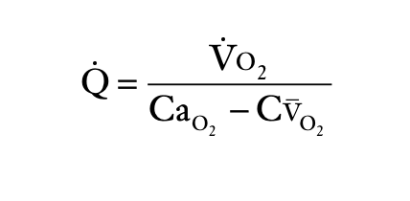

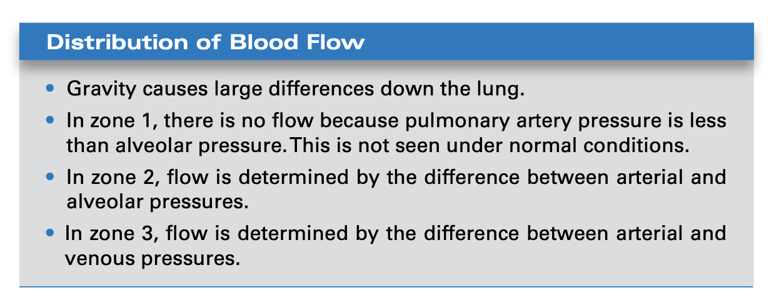

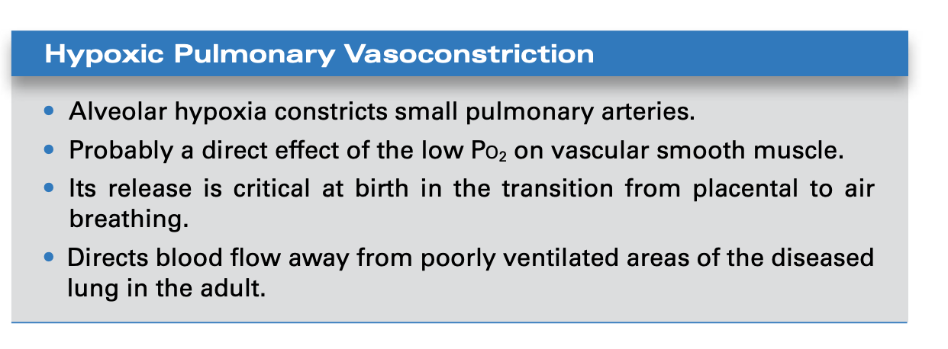

Starling’s equation:



The force tending to push fluid *out* of the capillary is the capillary hydrostatic pressure minus the hydrostatic pressure in the interstitial fluid, or Pc − Pi.

The force tending to pull fluid in is the colloid osmotic pressure of the proteins of the blood minus that of the proteins of the interstitial fluid, or πc -πi.

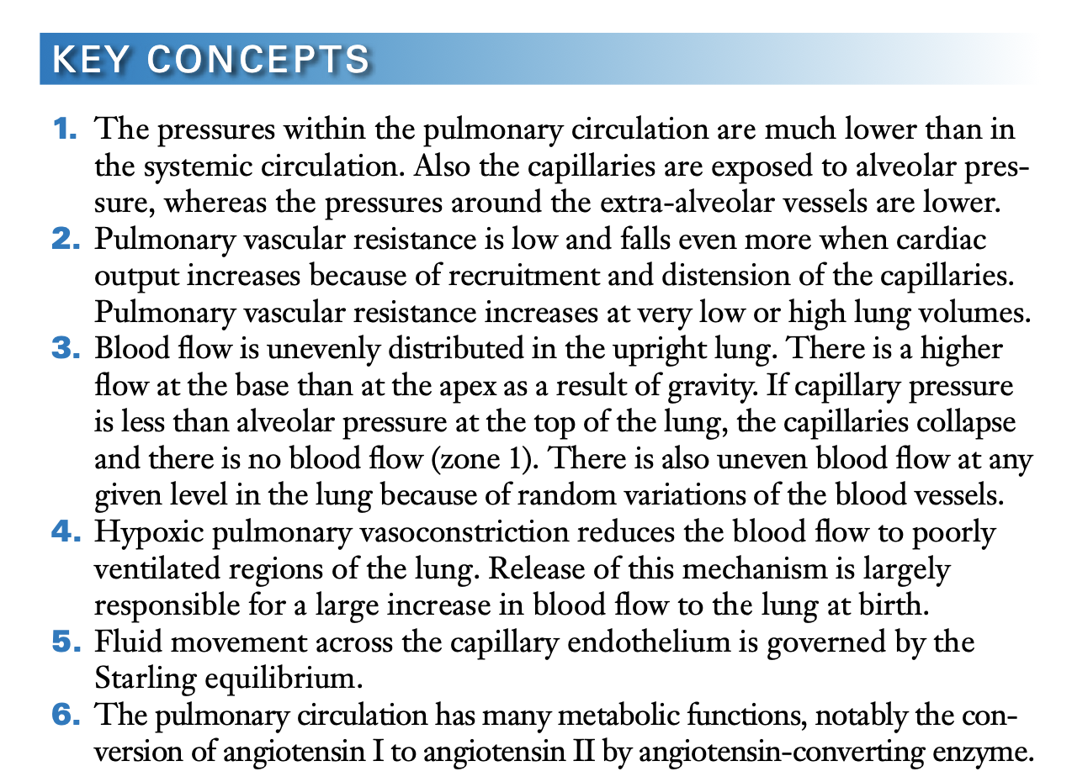

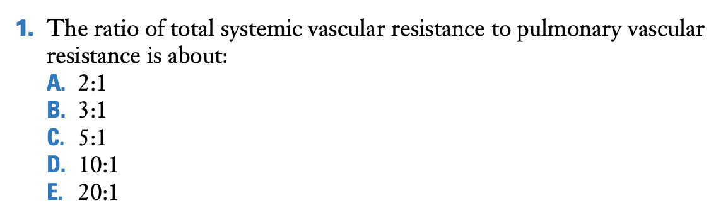

D

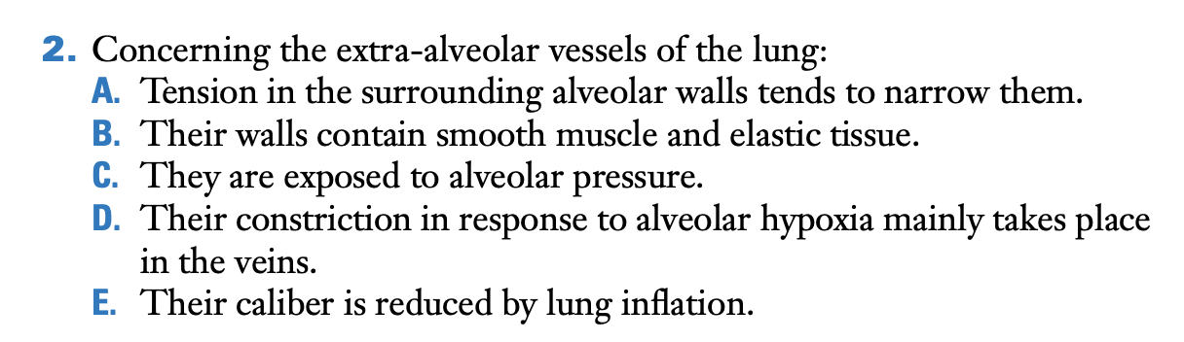

B.

The other choices are incorrect because the tension in the surrounding alveolar walls tends to pull the extra-alveolar vessels open, these vessels are not exposed to alveolar pressure, hypoxic pulmonary vasoconstriction occurs mainly in the small arteries, and the caliber of the extra-alveolar vessels is increased by lung inflation (see Figures 4.2 and 4.6).

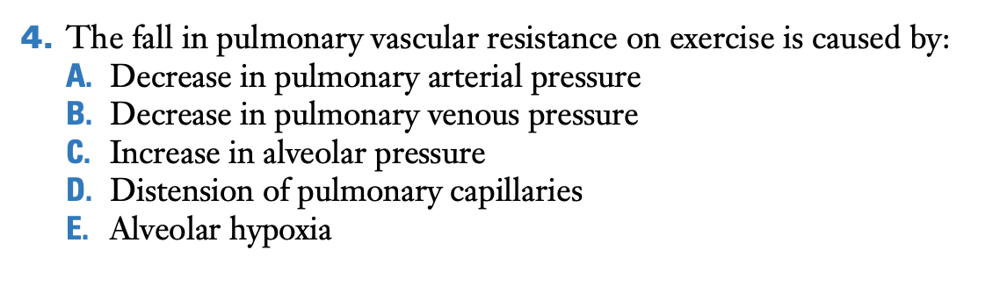

D.

The fall in pulmonary vascular resistance on exercise is caused by distension of pulmonary capillaries

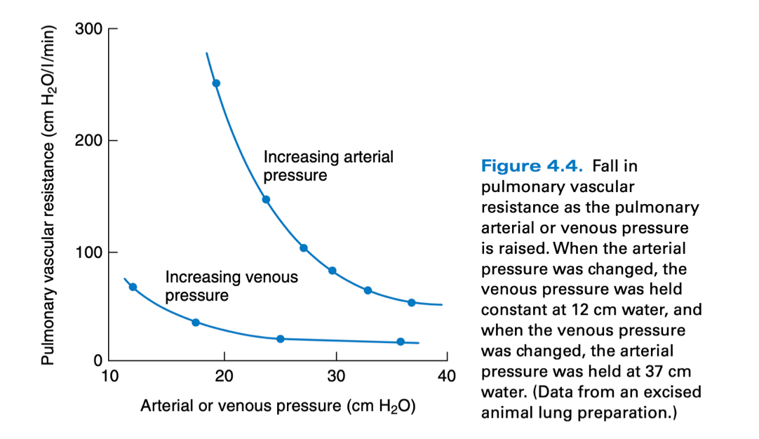

Distension of pulmonary capillaries lowers their vascular resistance. However, a decrease in both pulmonary arterial and pulmonary venous pressure reduces capillary pressure (other things remaining equal), and resistance therefore rises. The same is true of an increase in alveolar pressure, which tends to compress the capillaries. Alveolar hypoxia increases vascular resistance because of hypoxic pulmonary vasoconstriction.

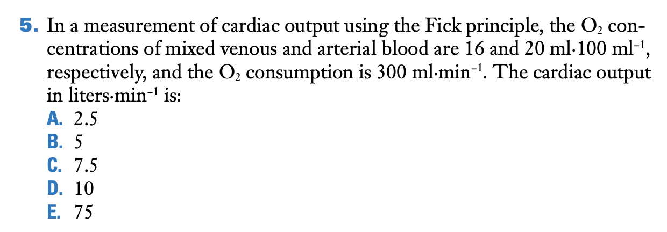

C.

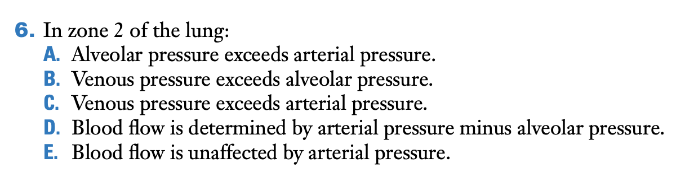

In zone 2 of the lung blood flow is determined by arterial minus alveolar pressure.

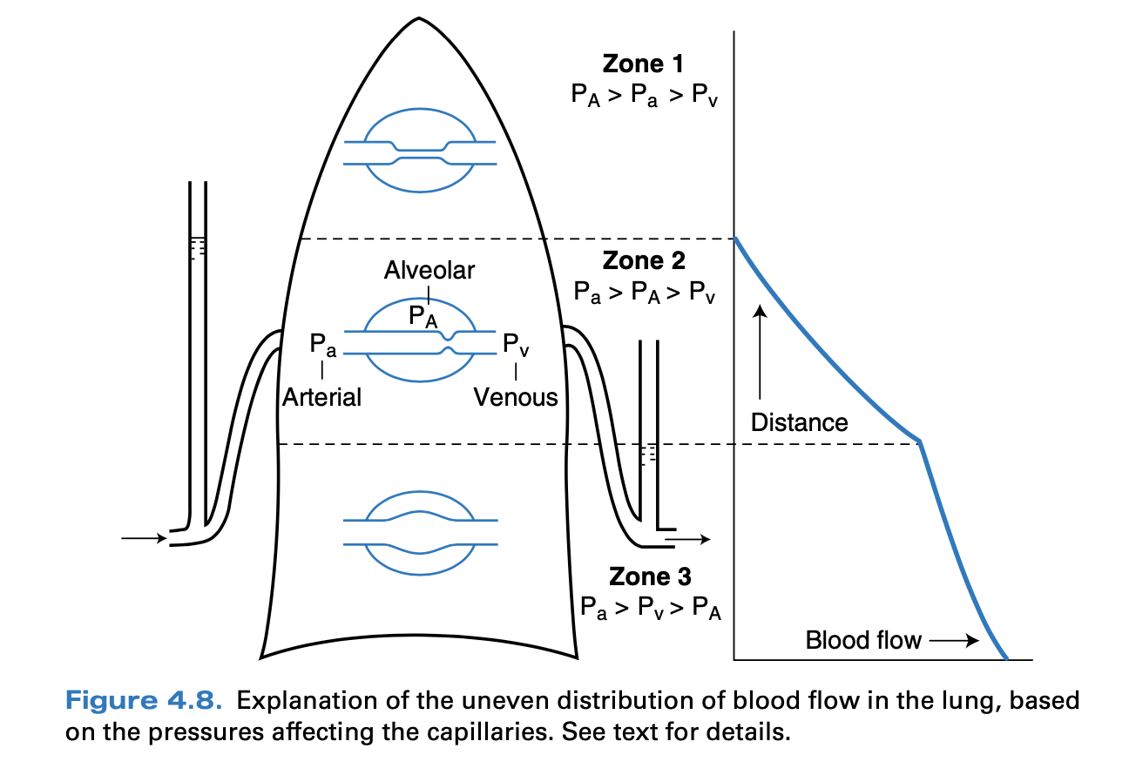

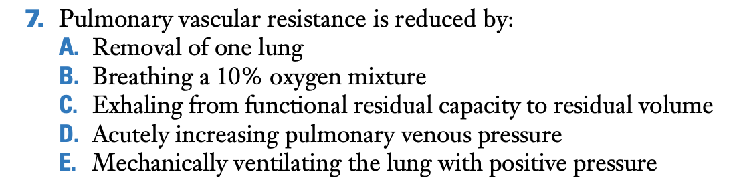

D.

Acutely increasing pulmonary venous pressure will raise capillary pressure and result in recruitment and distension of the capillaries. The other choices are incorrect because removing one lung greatly reduces the vascular bed, 10% oxygen breathing results in hypoxic pulmonary vasoconstriction, reducing lung volume to residual volume increases the resistance of the extra-alveolar vessels, and mechanically ventilating the lung with positive pressure increases the alveolar pressure and therefore tends to compress the capillaries.

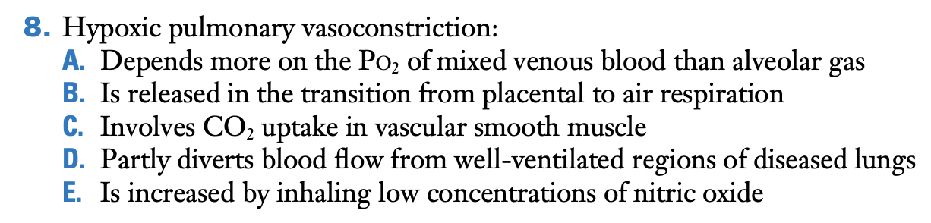

B.

Hypoxic pulmonary vasoconstriction is released in the transition from placental to air respiration.

The great reduction in pulmonary vascular resistance during the transition from placental to air respiration is largely brought about by the release of hypoxic pulmonary vasoconstriction. The PO2 of alveolar gas is much more important than the PO2 of mixed venous blood; CO2 uptake is irrelevant; the constriction partly diverts blood flow from poorly ventilated, not well-ventilated regions of diseased lungs; and the inhalation of nitric oxide partly reverses hypoxic pulmonary vasoconstriction.

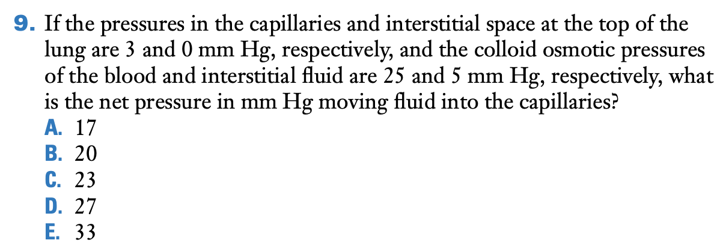

A.

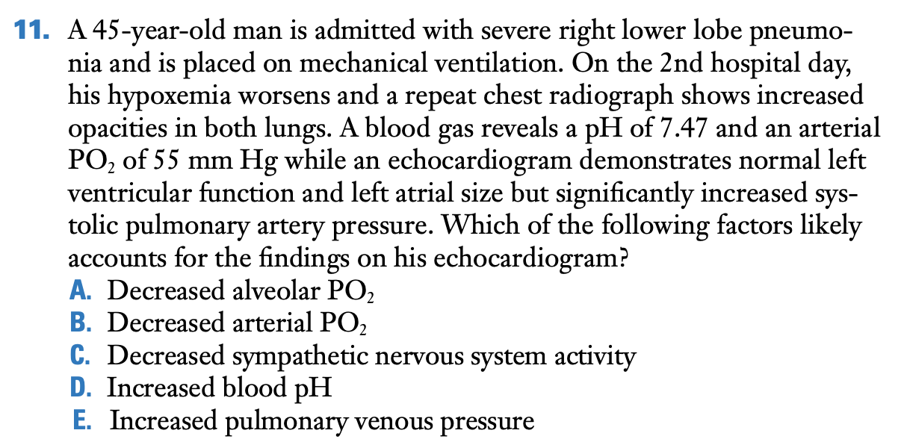

A.

The elevated pulmonary artery pressure on echocardiogram is most likely related to *hypoxic pulmonary vasoconstriction.* The stimulus for this is a decreased alveolar PO2 rather than the arterial PO2. Increased pulmonary venous pressure can increase pulmonary artery pressure, but would be expected in a patient with heart failure rather than a patient with pneumonia.

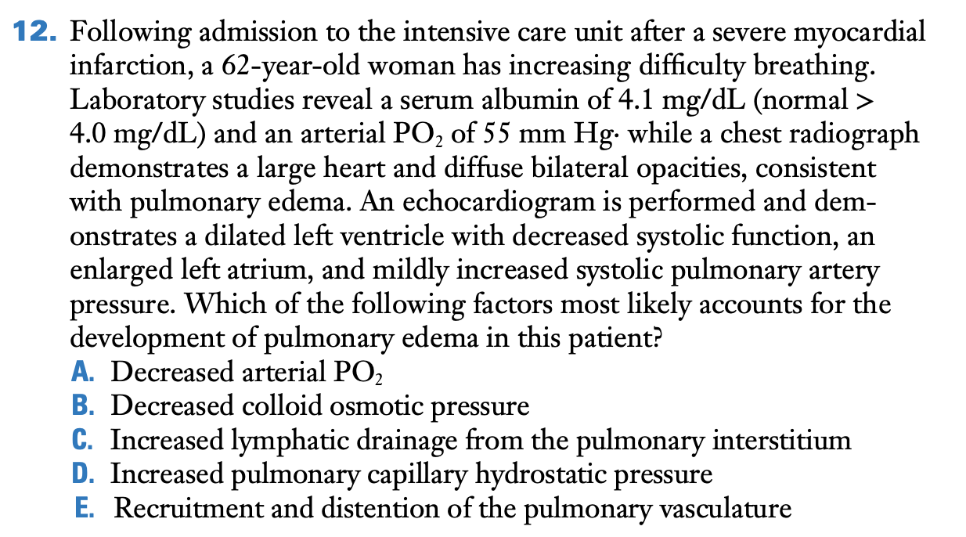

D.

Following admission to the intensive care unit after a severe myocardial infarction, a 62-year-old woman has increasing difficulty breathing, pulmonary edema, the patient has impaired systolic function following a myocardial infarction. This leads to increased left heart end-diastolic and pulmonary venous pressures, which raise pulmonary capillary hydrostatic pressure. The result is an imbalance of the Starling forces and movement of fluid out of the capillaries. The decreased PO2 is a consequence of pulmonary edema while colloid osmotic pressure would be normal given her normal albumin concentration.

# CHAPTER 5 – VENTILATION-PERFUSION RELATIONSHIP how matching of gas and blood determines gas exchange

Relationship between alveolar ventilation and arterial PCO2:

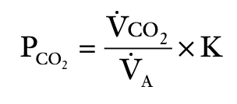

Alveolar gas equation:

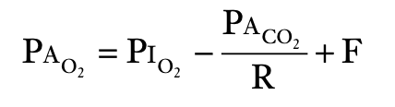

Shunt fraction:

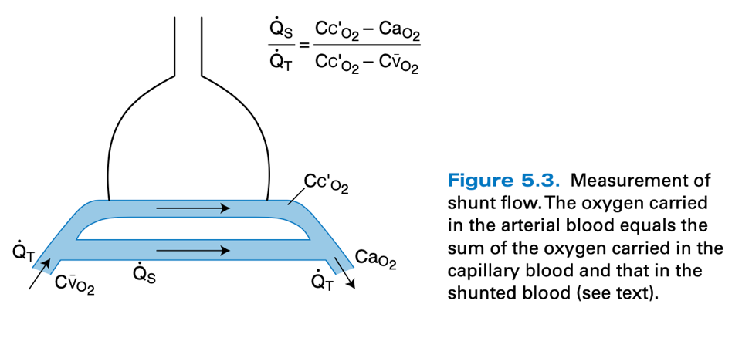

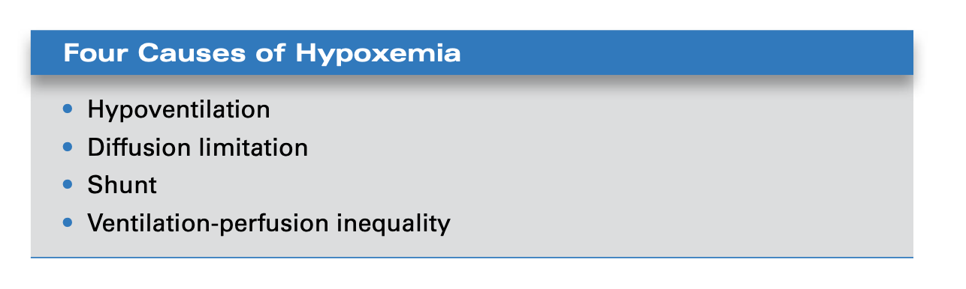

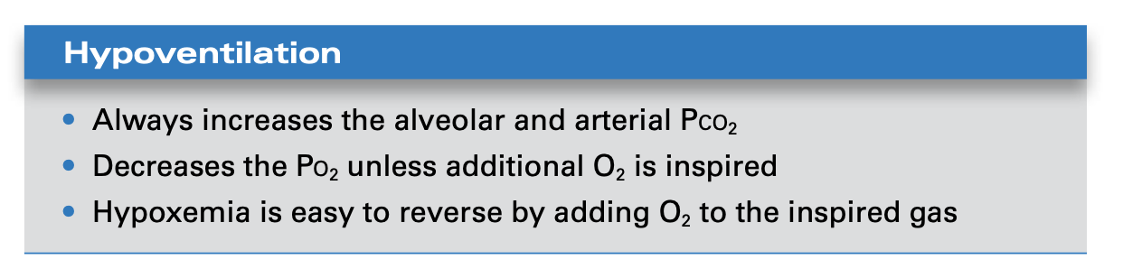

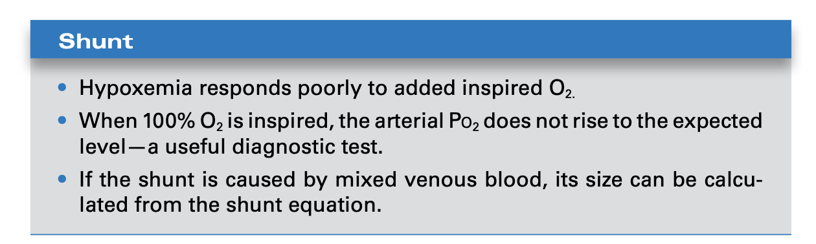

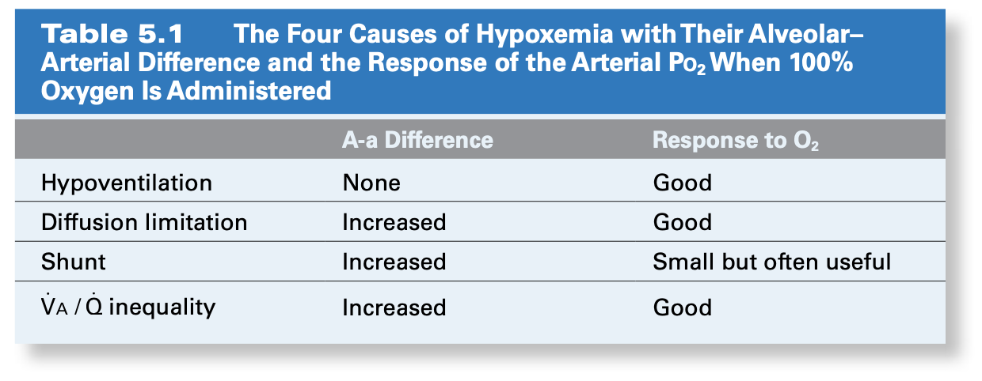

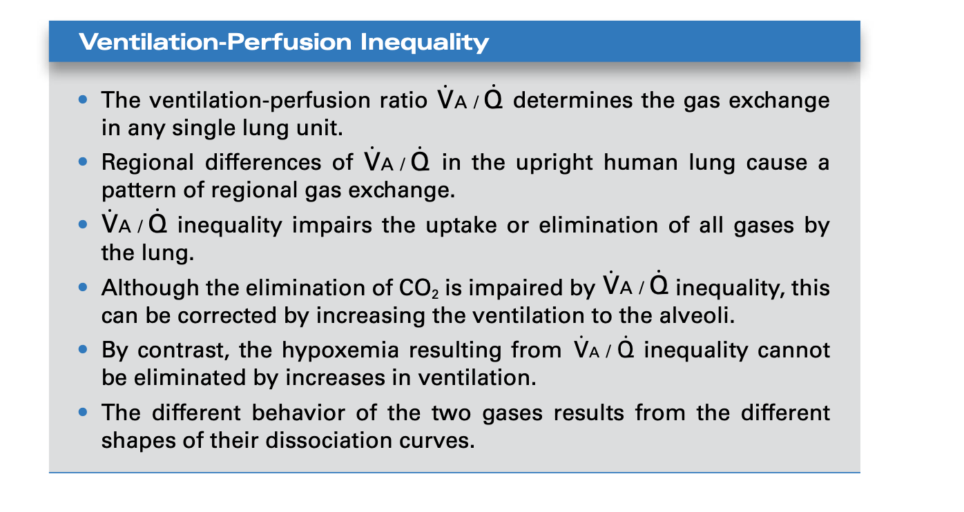

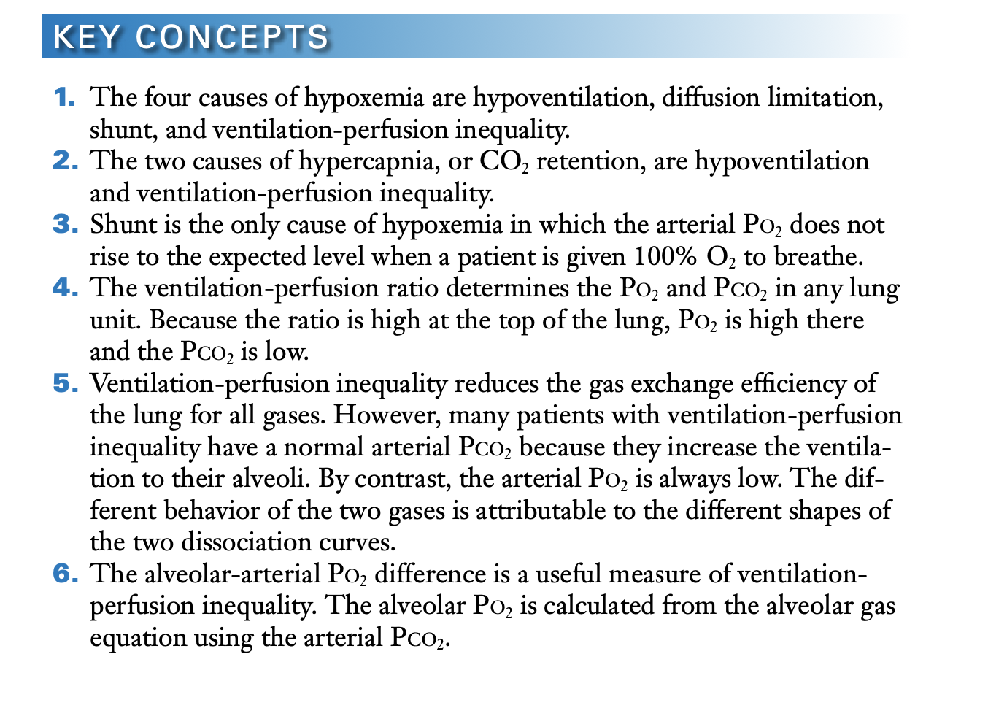

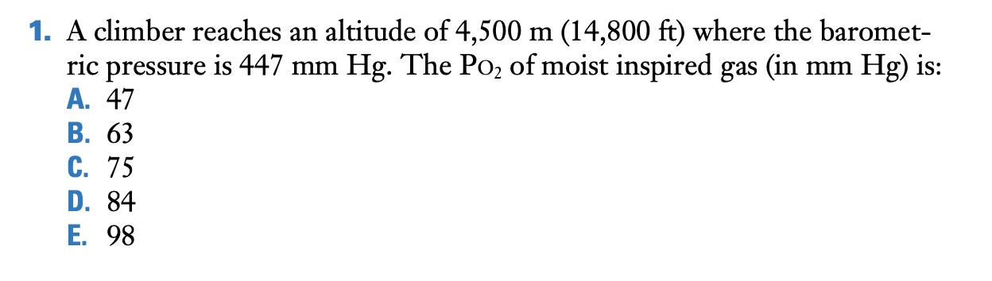

D.

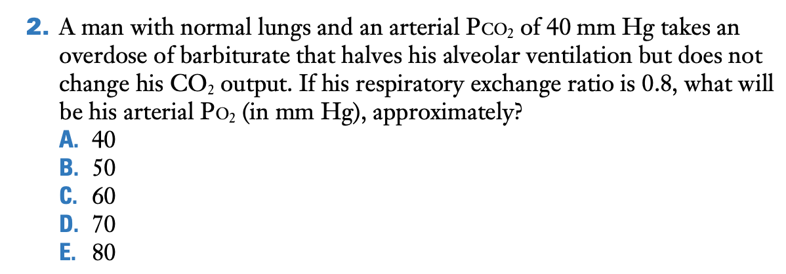

B.

if the CO2 output is unchanged, the PalvCO2 (PalvCo2) is inversely proportional to the alveolar ventilation. Therefore, since alveolar ventilation was halved, the arterial PCO2 was increased from 40 to 80 mm Hg. Then we use the alveolar gas equation

PalvO2 = PI −PalvCO2 /R+F

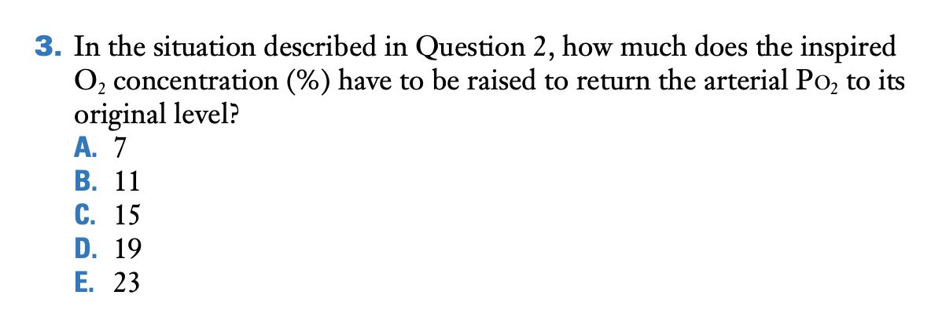

A.

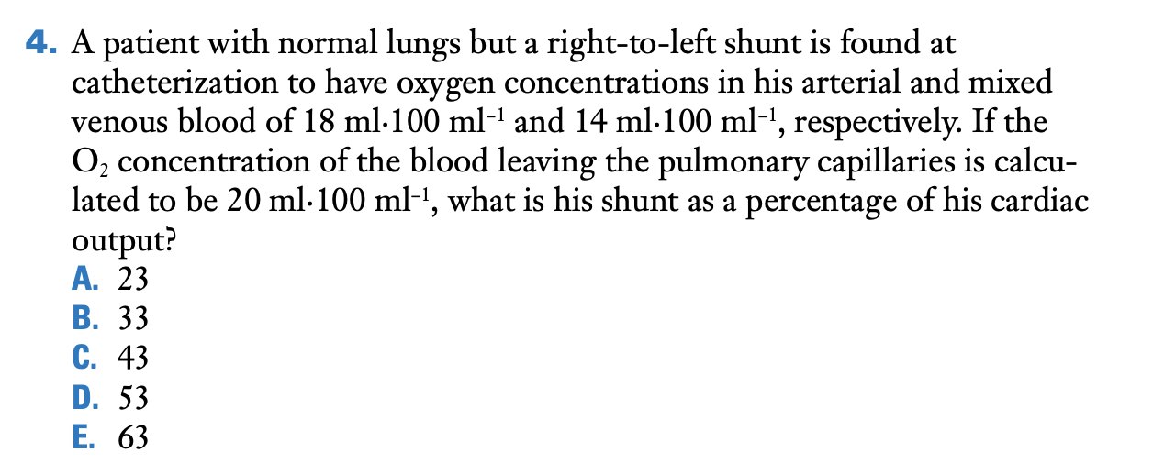

B.

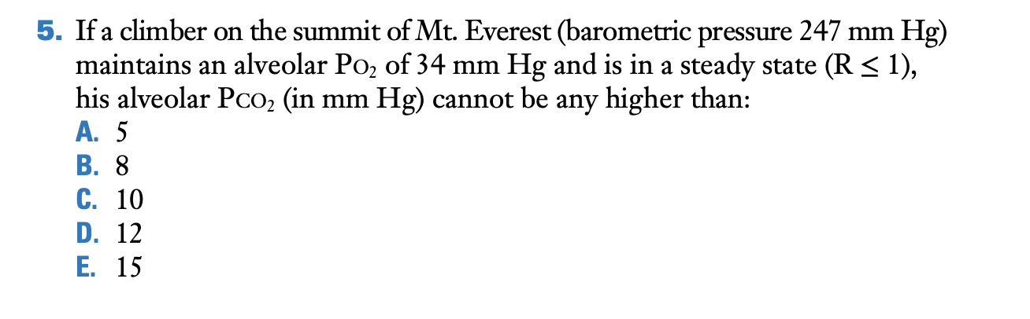

B.

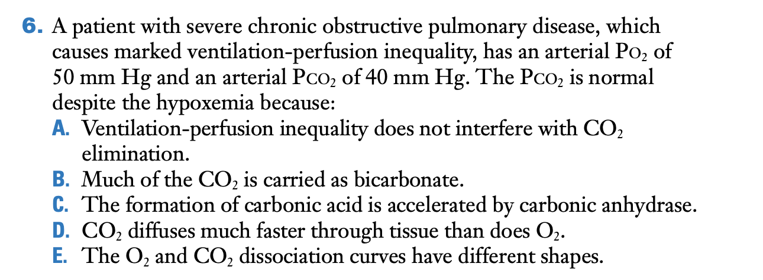

A.

The effects of ventilation-perfusion inequality on O2 and CO2 transfer by the lung:

VA /Q inequality impairs the transfer of both O2 and CO2 so that, other things being equal, this patient would have both a low arterial PO2 and high PCO2. However, by increasing the ventilation to the alveoli, the PCO2 can be brought back to normal, but the PO2 cannot. The reason for this is the different shapes of the O2 and CO2 dissociation curves. VA /Q does interfere with CO2 elimination. The statements that much of the CO2 is carried as bicarbonate, the formation of carbonic acid is accelerated by carbonic anhydrase, and CO2 diffuses much faster through tissue than does O2 are true but are not the explanation for the normal PCO2 despite the hypoxemia.

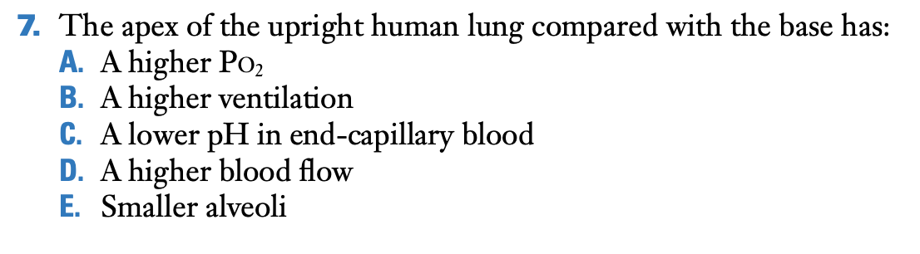

A.

The apex of the upright human lung has a high ventilation-perfusion ratio (see Figures 5.8 to 5.10). Therefore, the apex has a higher alveolar PO2 than does the base. The other choices are incorrect because the ventilation of the apex is lower than that of the base, the pH in end-capillary blood is higher because of the reduced PCO2 at the apex, the blood flow is lower as already stated, and the alveoli are larger because of the regional differences of intrapleural pressure.

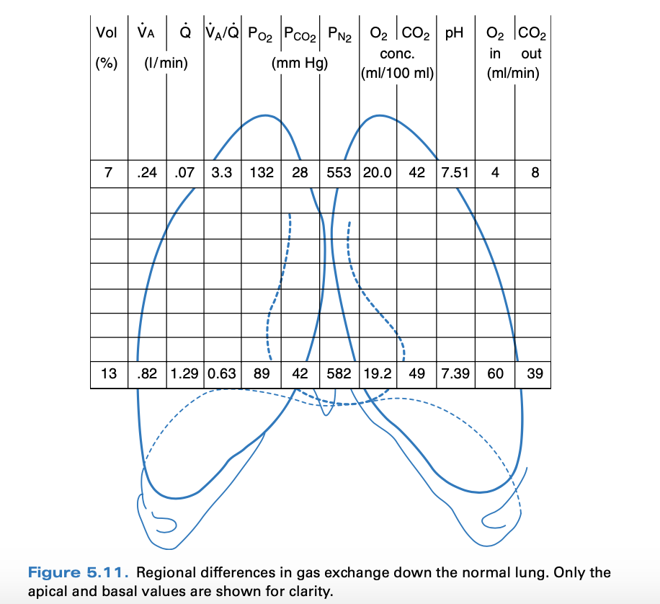

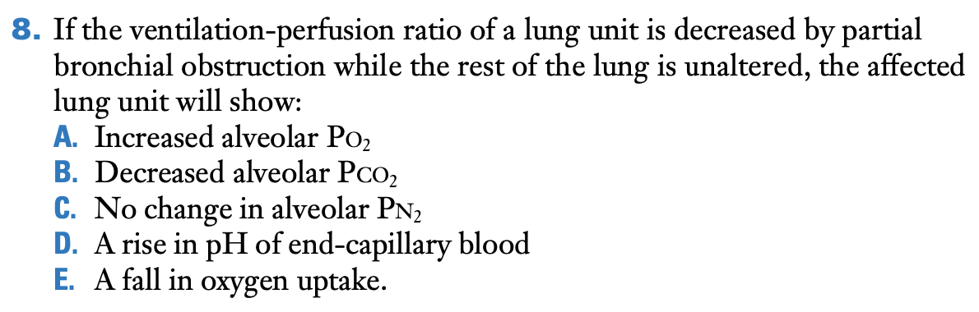

E.

A decreased ventilation-perfusion ratio reduces the alveolar PO2 and therefore the oxygen uptake by the lung unit. The other choices are incorrect because the unit will show a decreased alveolar PO2 as already stated, an increased alveolar PCO2, a change in alveolar PN2 (in fact a small rise), and a reduction in the pH of end-capillary blood because of the increased PCO2.

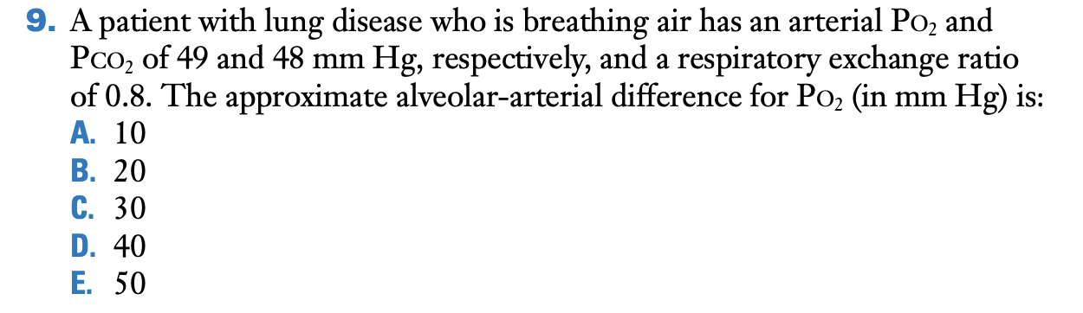

D.

A patient with lung disease who is breathing air has an arterial PO2 and PCO2 of 49 and 48mm Hg, respectively, and a respiratory exchange ratio of 0.8. The approximate alveolar-arterial difference for PO2 (in mm Hg) is: PAO2 = PIO2 - PACO2 / R = 89 mmHg. Difference: 89 – 49 = 40 mmHg.

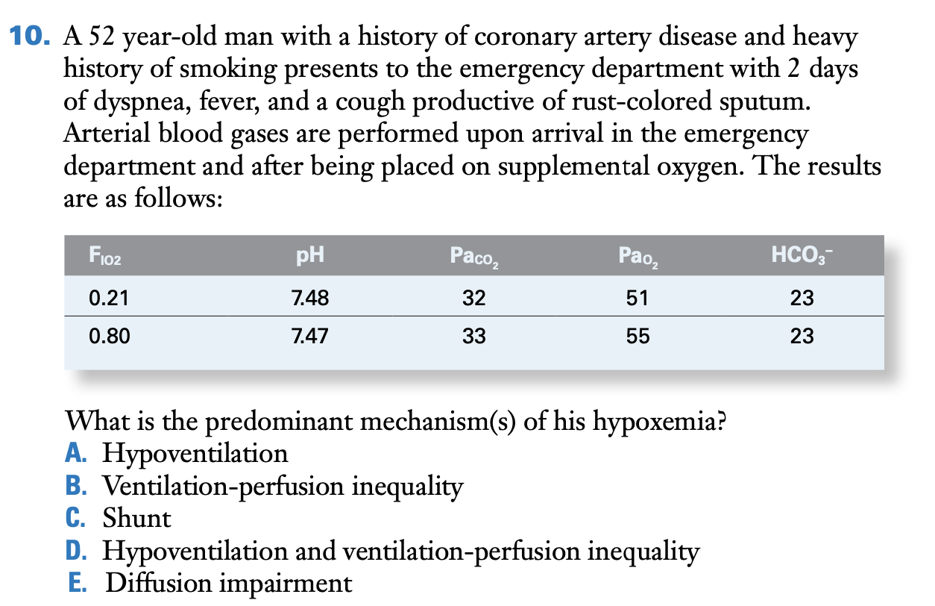

C.

When the patient is placed on supplemental oxygen, the arterial PO2 increases by only a small amount. This is consistent with shunt, which, in this case, may be the result of pneumonia. If the patient had predominantly ventilation-perfusion inequality, the arterial PO2 would have risen to a much greater extent with supplemental oxygen. Hypoventilation is not present given the low arterial PCO2, while diffusion impairment rarely causes hypoxemia in patients at sea level

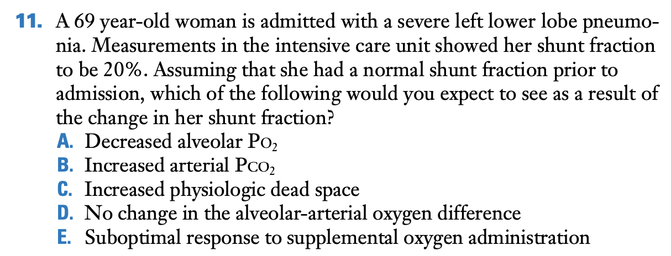

E.

When the shunt fraction is increased, the response to supplemental oxygen is less than the response seen with oxygen administration in patients with other causes of hypoxemia. Increases in the shunt fraction leads to increases in the alveolar-arterial oxygen difference but do not affect the alveolar PO2. Although a shunt tends to increase the arterial PCO2 the chemoreceptors can easily raise the ventilation sufficiently to keep the PCO2 normal.

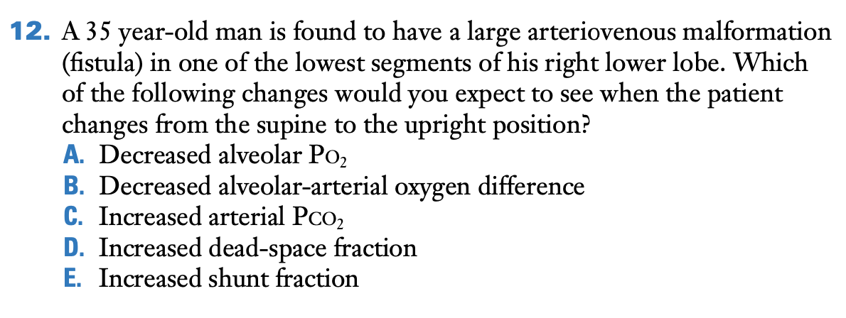

E.

With an arteriovenous malformation, pulmonary arterial blood finds its way into the pulmonary veins without going through ventilated regions of the lung, that is, it is a shunt. Since blood flow to the lower lobe where the shunt is located will increase when the patient moves from the supine to the upright position, the shunt will increase. The other choices are incorrect. The alveolar PO2 will not be affected. The alveolar-arterial difference will increase, there is no increase in the arterial PCO2 for the reason given in the answer to Question 11, and there is no change in the dead space.

# CHAPTER 6 – GAS TRANSPORT BY THE BLOOD: how gases are moved to and from the peripheral tissues

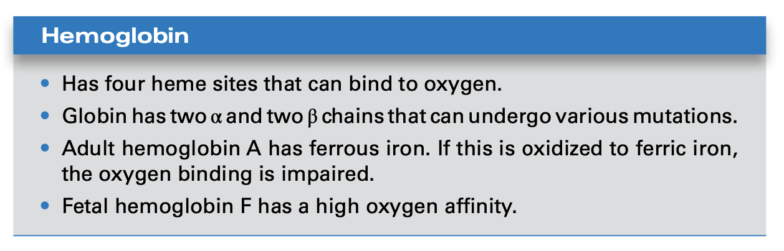

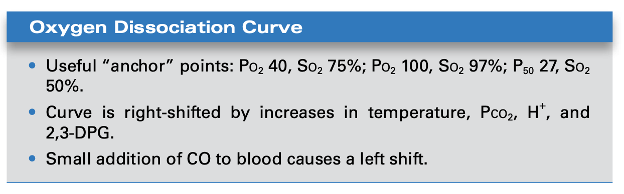

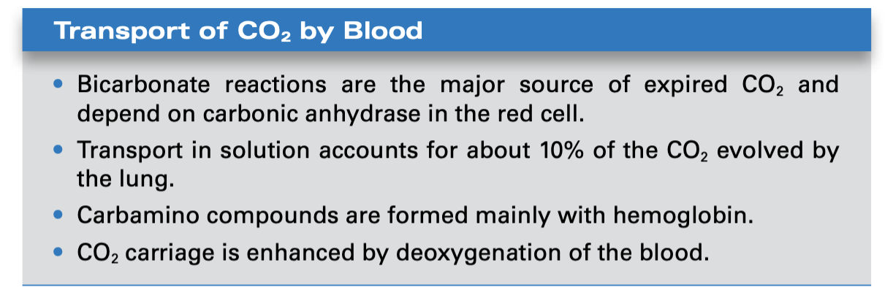

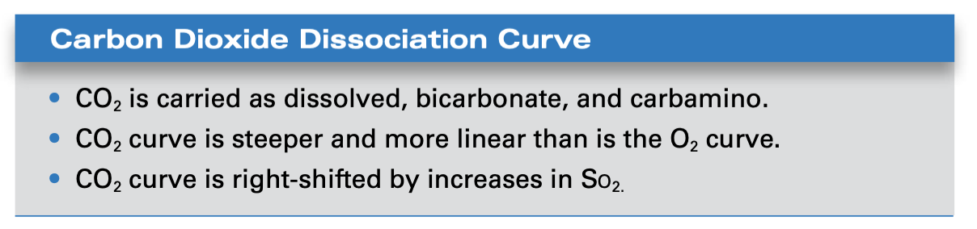

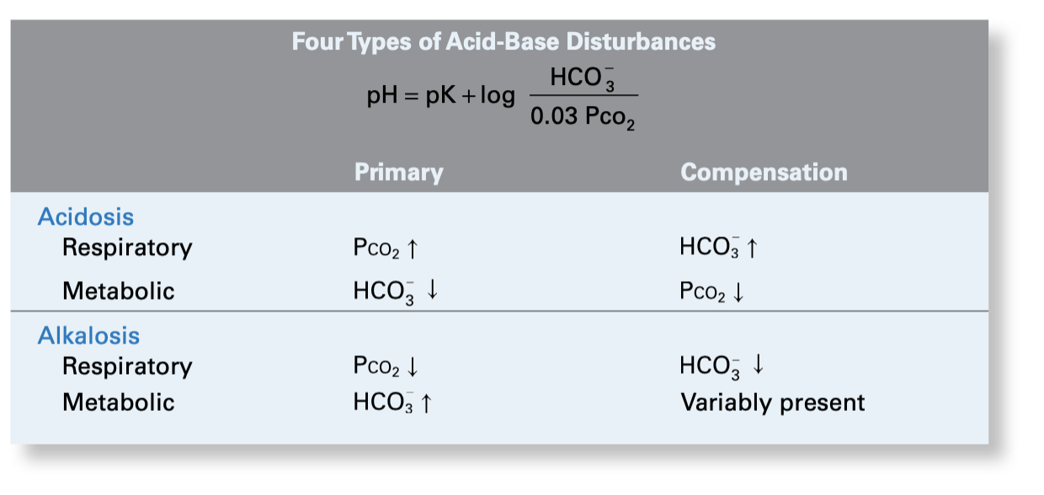

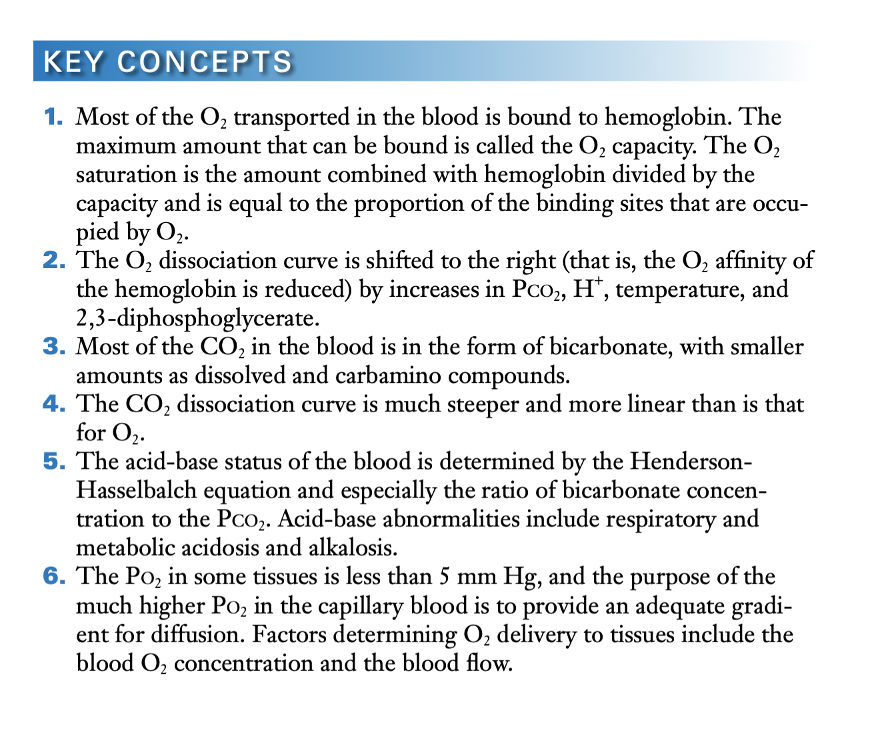

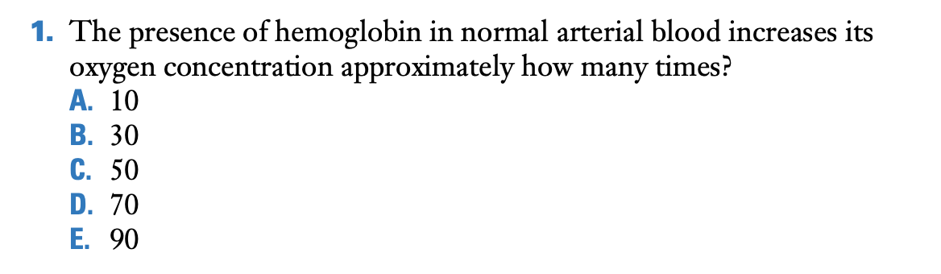

D is correct. Normal arterial blood has a PO2 of about 100 mm Hg. The concentration of oxygen in the absence of hemoglobin is the dissolved oxygen, which is 100 × 0.003, or 0.3 ml O2 ·100 ml−1 blood. However, normal arterial blood contains about 15 g·100 ml−1 of hemoglobin, and each gram can combine with 1.39 ml O2. Since the oxygen saturation of normal arterial blood is about 97%, the total oxygen concentration is given by (1.39 × 15 × 97/100) + 0.3 ml O ·100 ml−1 blood. This is about 20.5 as opposed to the dissolved oxygen concentration of 0.3 ml O ·100 ml−1 blood. Therefore, the presence of hemoglobin increases the oxygen concentration about 70 times.

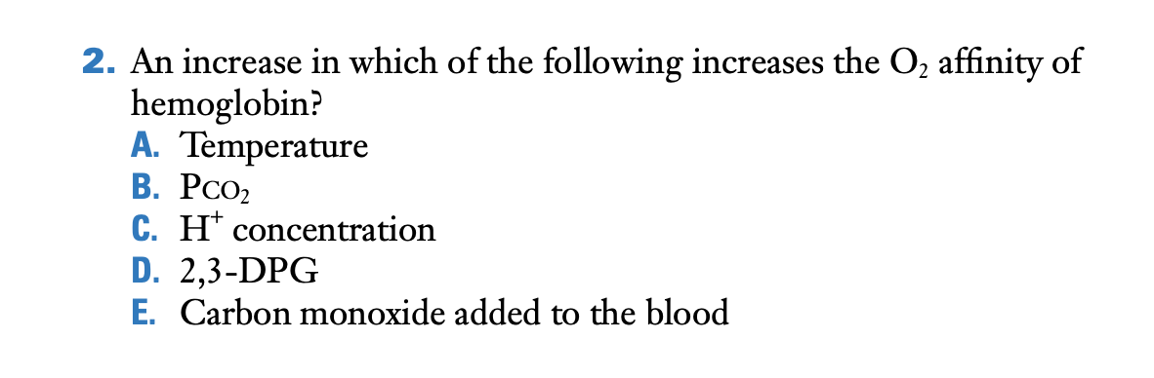

E. A small amount of carbon monoxide added to blood increases its oxygen affinity, that is, it causes a leftward shift of the O2 dissociation curve (see Figure 6.2). All the other choices reduce the oxygen affinity of hemoglobin, that is, they shift the dissociation curve to the right (see Figure 6.3).

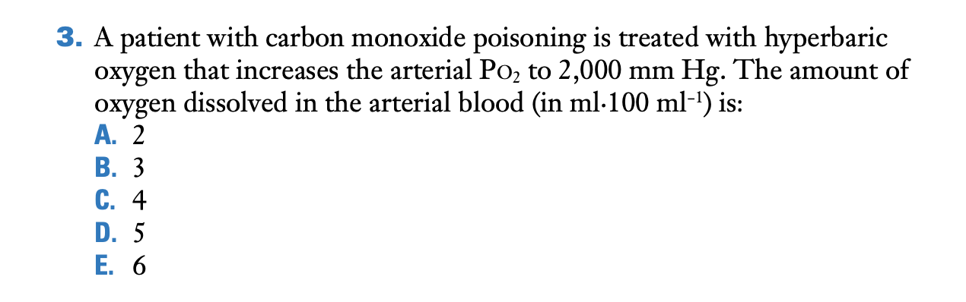

E. Since the solubility of oxygen is 0.003 ml O ·100 ml−1 blood, an arterial PO2 of 2,000 mm Hg will increase the concentration of the dissolved oxygen to 6 ml O ·100 ml−1 blood. Note that this actually exceeds the normal arterial-venous difference for the oxygen concentration.

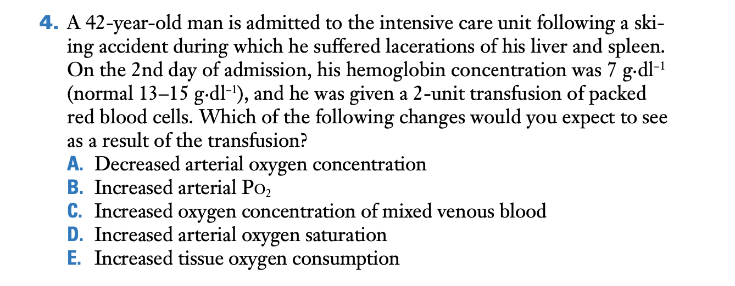

C.

With severe blood loss, arterial oxygen concentration and tissue oxygen delivery decrease. The peripheral tissues still need to extract the same amount of oxygen from the blood to satisfy their metabolism.  
As a result, there is a decrease in the mixed venous oxygen concentration. Following transfusion, oxygen delivery will improve leading to a rise in mixed venous oxygen concentration. Transfusion will not change the arterial PO2, only the O2 concentration, and will not change tissue oxygen consumption. While transfusion increases oxygen concentration for any given PO2, the oxygen saturation for a given PO2 does not change.

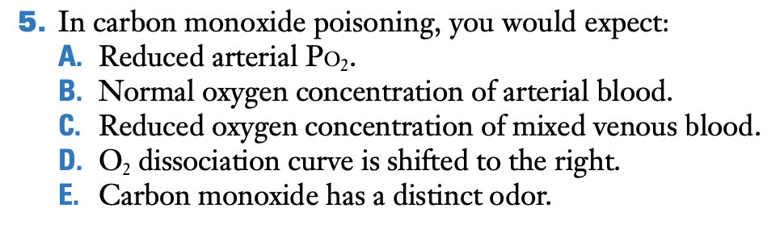

C.

Because the oxygen concentration of arterial blood is reduced, this must also be true of mixed venous blood, other things being equal. The other choices are incorrect. If the patient has normal lungs, the arterial PO2 will be normal, but of course the oxygen concentration of arterial blood will be reduced. Carbon monoxide shifts the O2 dissociation curve to the left, that is, it increases the oxygen affinity of the hemoglobin. Carbon monoxide has no odor, which is one reason why it is so dangerous. See Table 6.1 for the changes.

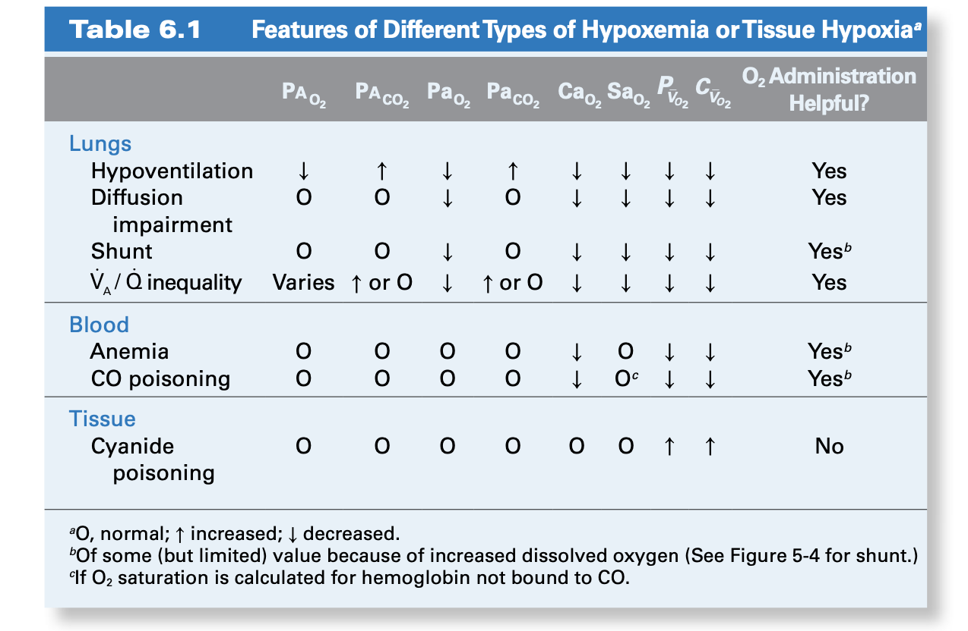

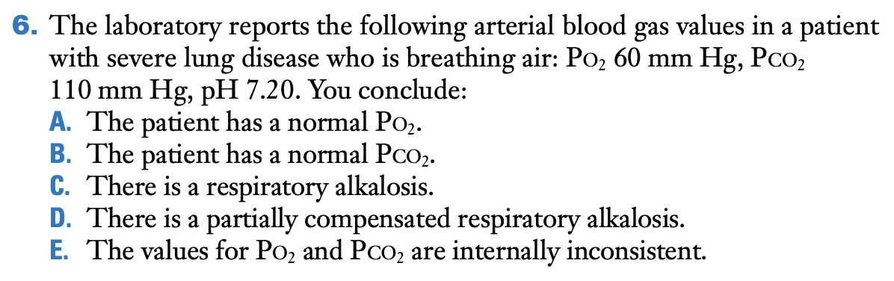

E. Since the patient is breathing air, the inspired PO2 is about 149 mm Hg. Using the alveolar gas equation, the alveolar PO2 will  
be about 149 – 110, that is, 39 mm Hg for an R value of 1, and even less for an R value of less than 1. This is below the stated arterial PO2, which cannot be correct. In addition, the other four choices are clearly wrong. The patient does not have a normal PO2 or POC2, and there is an acidosis rather than an alkalosis.

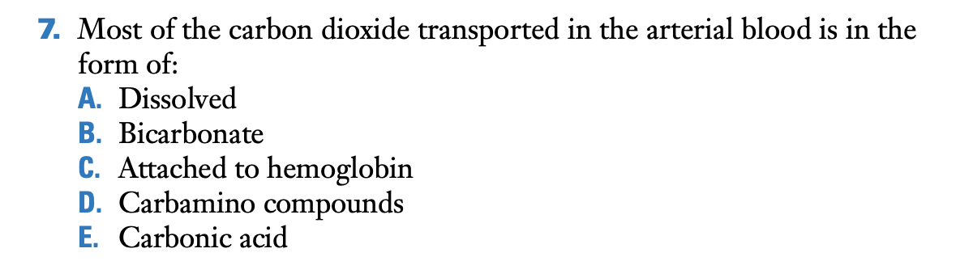

B.

As the first column of Figure 6.4 shows, about 90% of the CO2 transported in the arterial blood is in the form of bicarbonate. About 5% is dissolved, and another 5% is transported as carbamino compounds. The most important of these is carbaminohemoglobin.

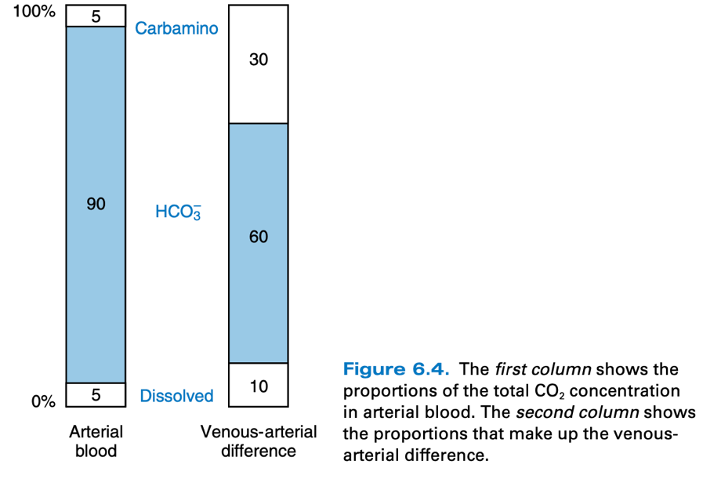

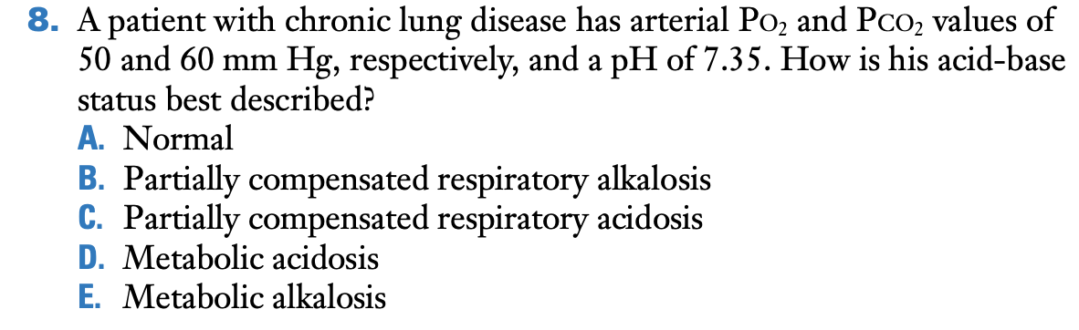

C.

The abnormally high PCO2 of 60 mm Hg and the reduced pH of 7.35 are consistent with a partially compensated respiratory acidosis. Figure 6-8A shows that if the PCO2 rises to 60 mm Hg and there is no renal compensation, the pH is less than 7.3. Therefore, the patient shows some compensation. The fact that the pH has not fully returned to the normal value of 7.4 means that the respiratory acidosis is only partially compensated. The other choices are incorrect because clearly the gas exchange with the high PCO2 is not normal, there is an acidosis rather than an alkalosis because the pH is reduced, and this is not a metabolic acidosis because the PCO is elevated.

Henderson-Hasselbalch equation:

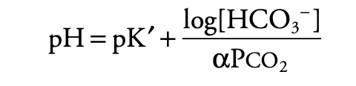

Plasma at 37oC, α = 0.03 and pK’ = 6.1 and pH:

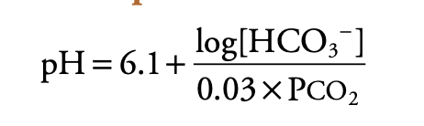

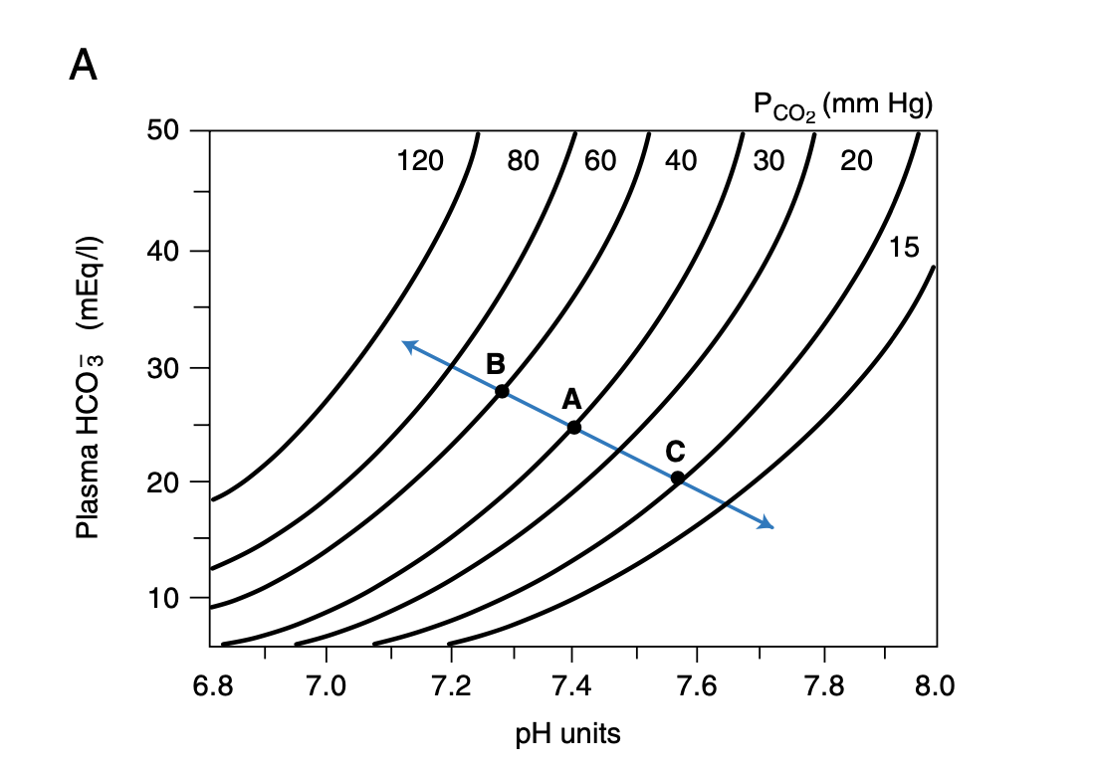

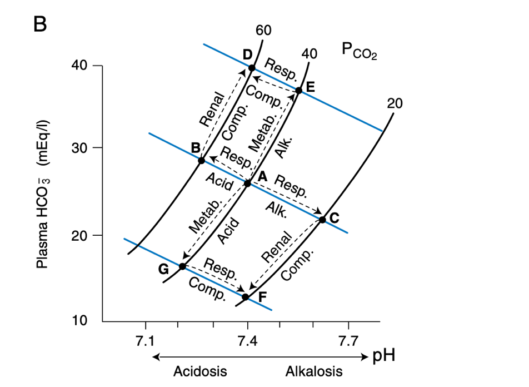

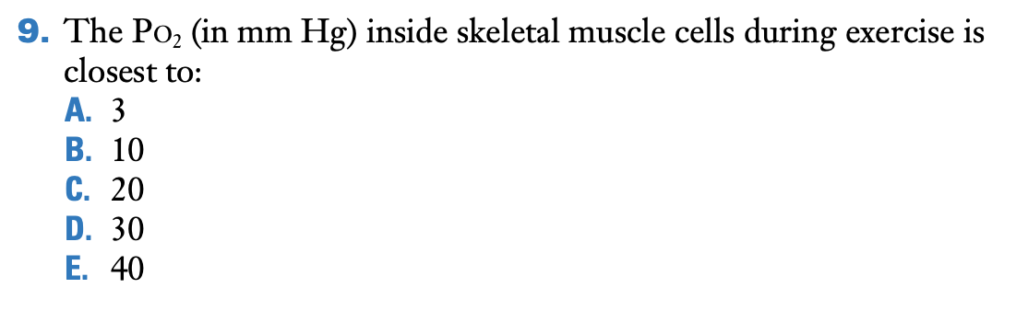

A.

As described in the section titled “Blood-Tissue Gas Exchange,” the PO2 inside skeletal muscle cells is around 3 mm Hg. The blood in the peripheral capillaries has much higher PO2 values in order to enable the diffusion of oxygen to the mitochondria.

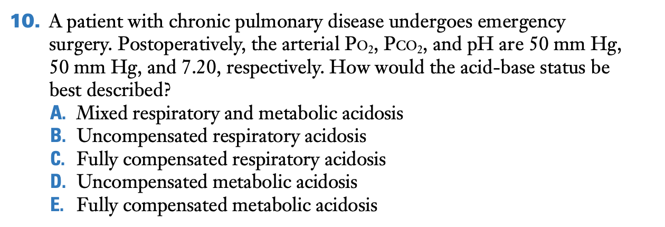

A.

There is a respiratory acidosis because the PCO2 is increased  
to 50 mm Hg and the pH is reduced to 7.20. However, there must be a metabolic component to the acidosis because as Figure 6-8A shows, a PCO2 of 50 will reduce the pH to only about 7.3 if the point moves along the normal blood buffer line. Therefore, there must be a metabolic component to reduce the pH even further. The other choices are incorrect because, as indicated above, an uncompensated respiratory acidosis would give a pH of above 7.3 for this PCO2. Clearly, the patient does not have a fully compensated respiratory acidosis because then the pH would be 7.4. There is not an uncompensated metabolic acidosis because the PCO2 is increased, indicating a respiratory component. Finally, there is not a fully compensated metabolic acidosis because this would give a pH of 7.4.

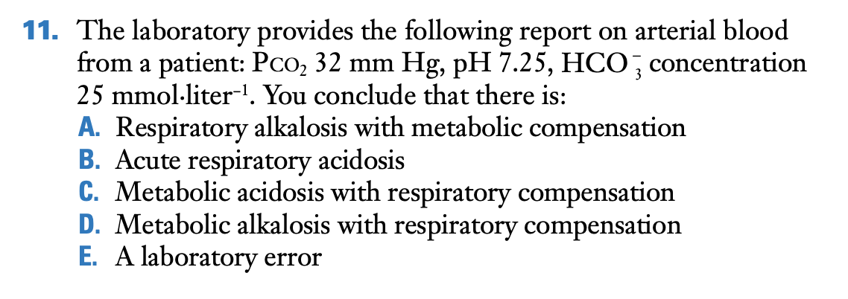

E.

A is incorrect because there is no metabolic compensation. In fact, the bicarbonate concentration is abnormally high. B is incorrect because the PCO2 is low, which is incompatible with a respiratory acidosis. C is incorrect because a metabolic acidosis requires an abnormally low bicarbonate concentration, which this patient does not have. D is incorrect because the patient has an acidosis, not an alkalosis. Therefore, the correct answer can be found by eliminating the other four. However, in addition, Figure 6.8A shows that there is no way that the three given values can coexist on the diagram. Therefore, there must be a laboratory error**.**

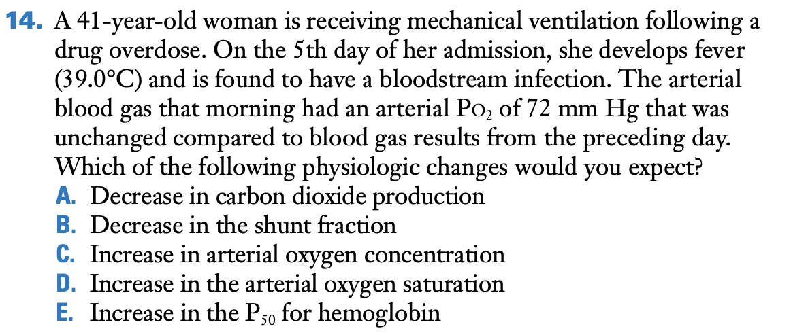

E.

Fever causes a rightward shift (i.e., increased P50) in the hemoglobin-oxygen dissociation curve such that at any given PO2, there will be a lower oxygen saturation and, therefore, lower oxygen concentration. Fever is associated with increased carbon dioxide production and is not by itself associated with an increased shunt fraction.

Shunt fraction:

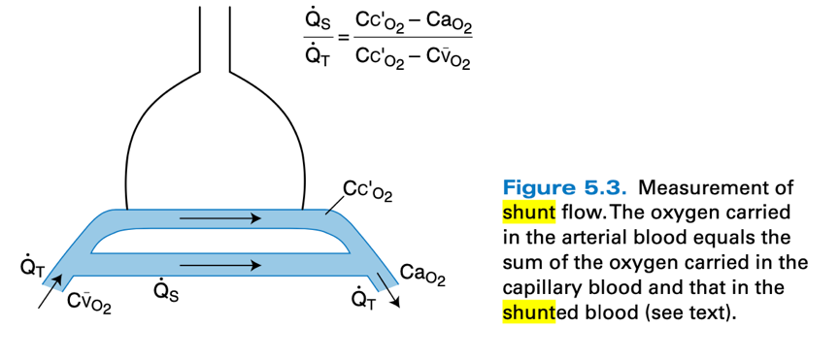

# CHAPTER 7 – MECHANICS OF BREATHING: how the lung is supported and moved

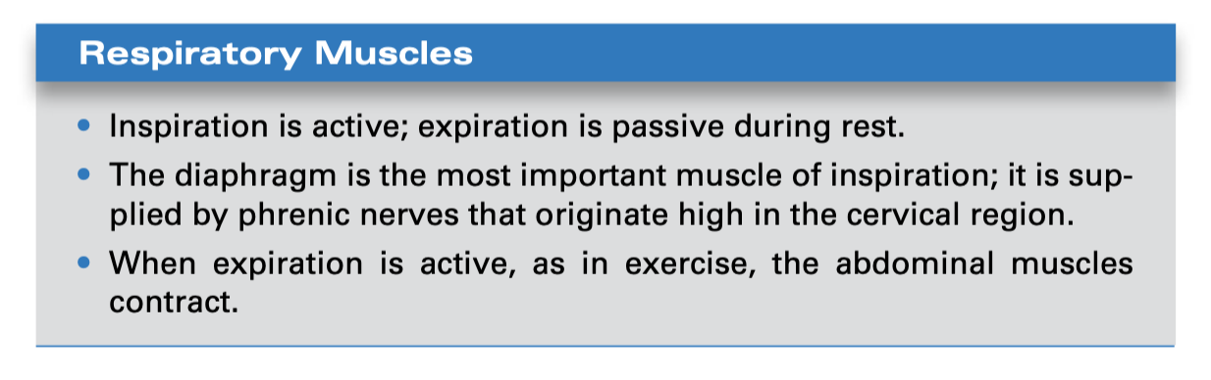

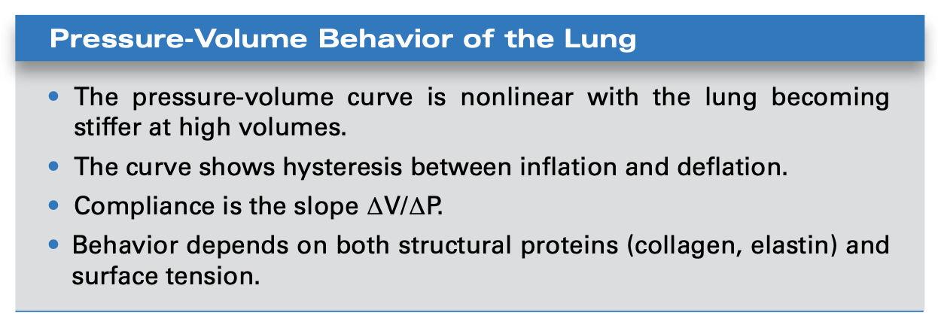

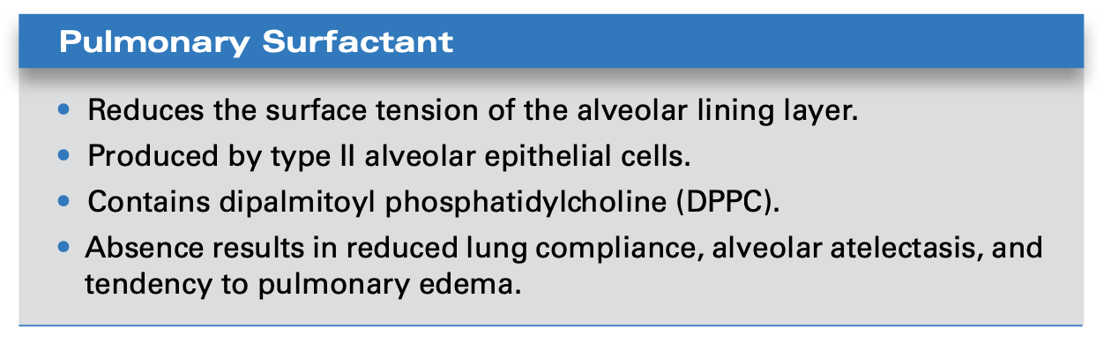

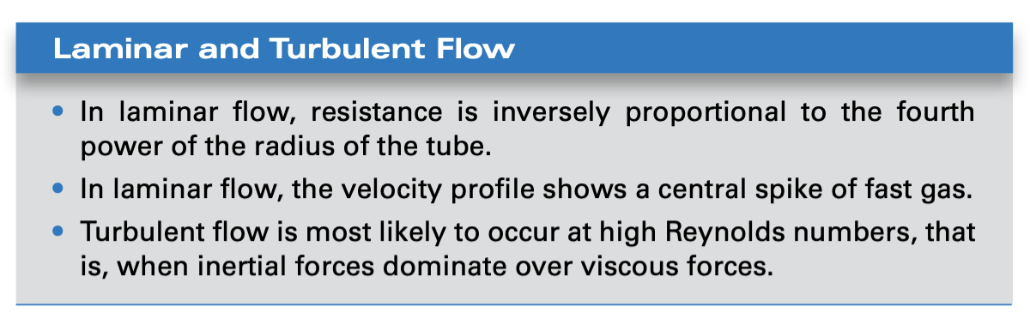

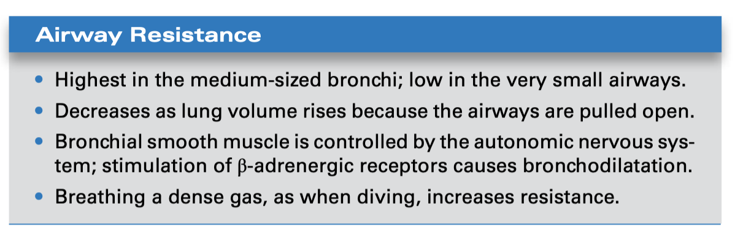

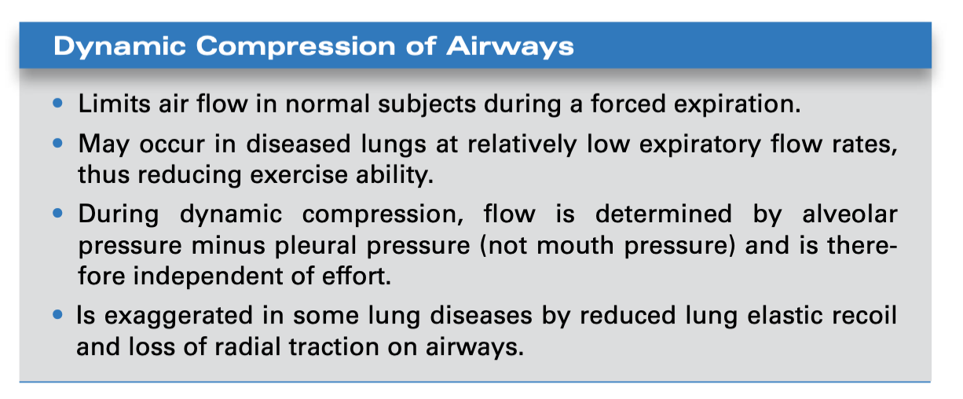

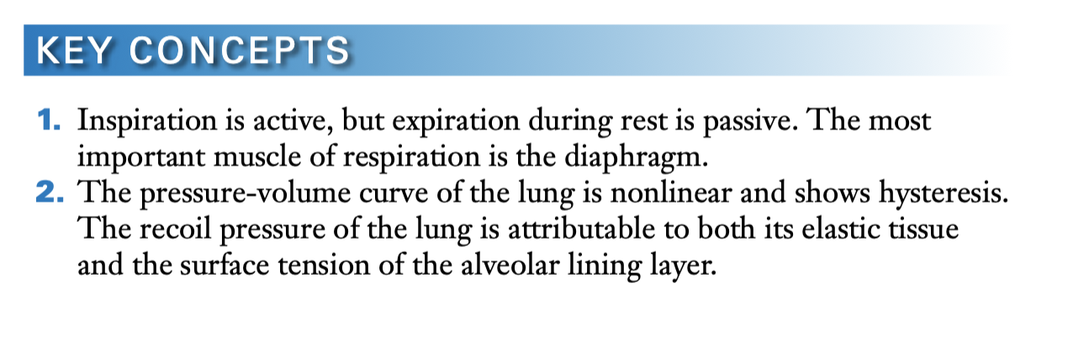  
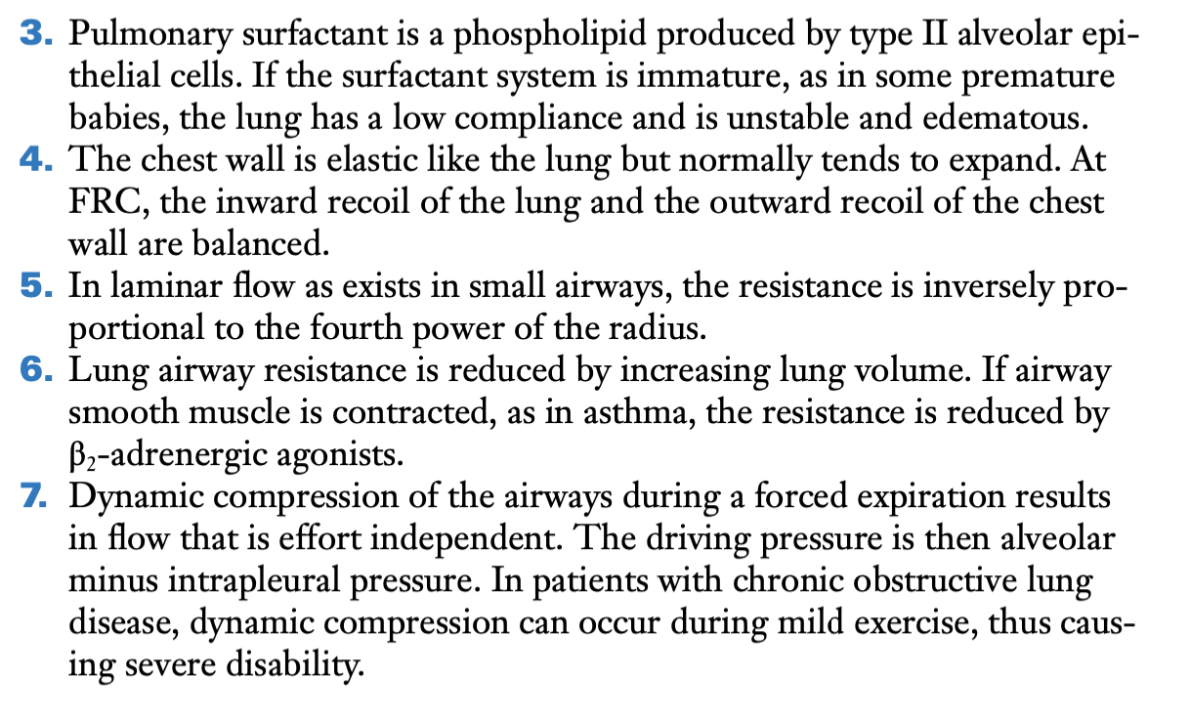

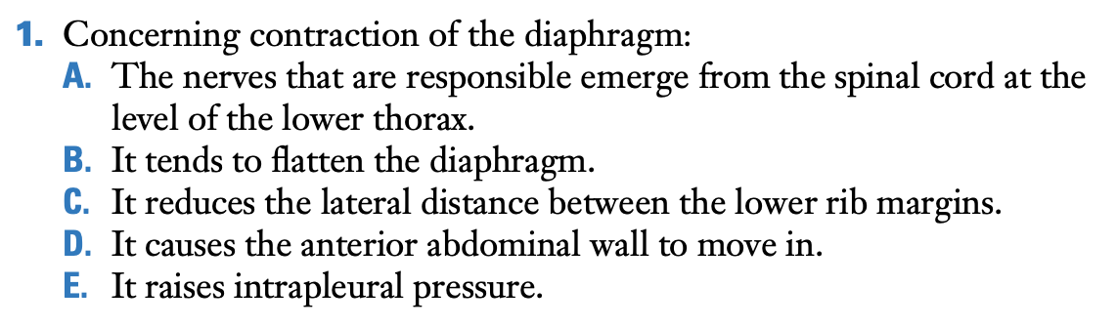

B.

When the diaphragm contracts, it becomes flatter as shown in Figure 7.1. The other choices are incorrect. The phrenic nerves that innervate the diaphragm come from high in the neck, that is, cervical segments 3, 4, and 5. Contraction of the diaphragm causes the lateral distance between the lower rib margins to increase and anterior abdominal wall to move out as also shown in Figure 7.1. The intrapleural pressure is reduced because the larger volume of the chest cage increases the recoil pressure of the lung.

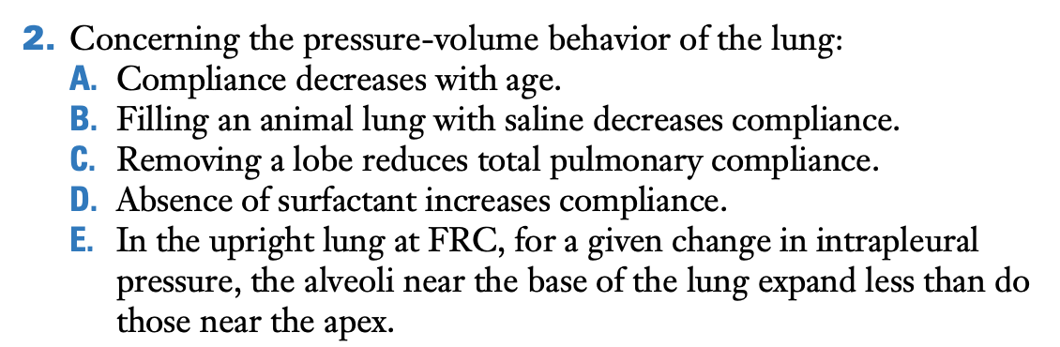

C.

If there is less lung, the total change in volume per unit change in pressure will be reduced. The other choices are incorrect. Compliance increases with age, filling a lung with saline increases compliance (Figure 7.5), absence of surfactant decreases compliance, and in the upright lung at FRC, inspiration causes a larger increase in volume of the alveolar at the base of the lung compared with those near the apex (Figure 7.8).

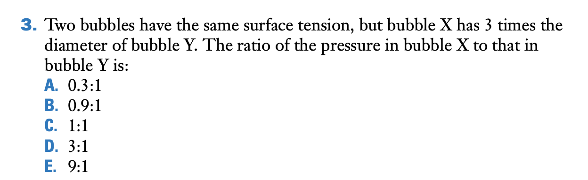

A.

Since bubble X has three times the radius of bubble Y, the ratio of pressures will be approximately 0.3:1.

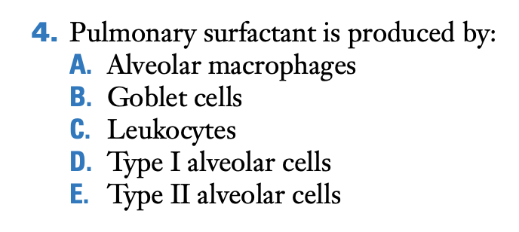

E.

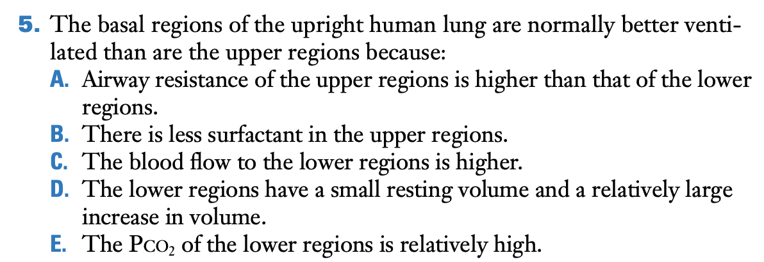

D is correct. As Figure 7.8 shows, the lower regions of the lung have a relatively small resting volume and large increase in volume compared with those near the top of the lung. The other choices are incorrect. The airway resistance of the upper regions is probably somewhat less than is that of the lower regions because the parenchyma is better expanded there. However, in any event, this is not the explanation of the difference in ventilation. There is no evidence that there is less surfactant in the upper regions of the lung. It is true that the blood flow to the lower regions is higher than to the upper regions, but this is not relevant here. It is also true that the PCO2 of the lower regions is relatively high compared with the upper regions, but this is not the explanation of the difference in ventilation.

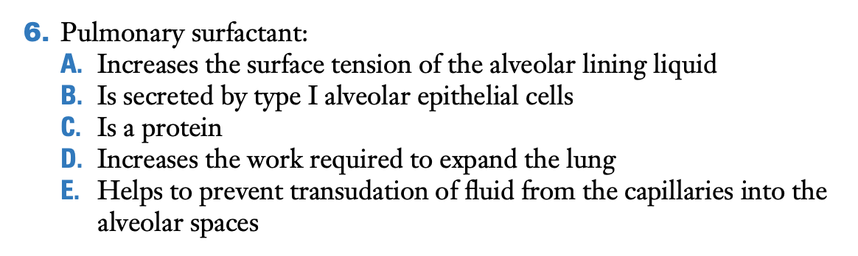

E is correct. The presence of surfactant reduces the surface tension of the alveolar lining layer and therefore the inward pull of the alveolar wall (Figure 7.4B). This in turn means that the hydrostatic pressure in the interstitium around the capillaries is less negative when surfactant is present. As a result, this helps to prevent transudation of fluid from the capillaries into the interstitium or into the alveolar spaces. The other choices are incorrect. Surfactant decreases the surface tension of the alveolar lining liquid, it is secreted by type II alveolar epithelial cells, it is a phospholipid, and it decreases the work required to expand the lung.

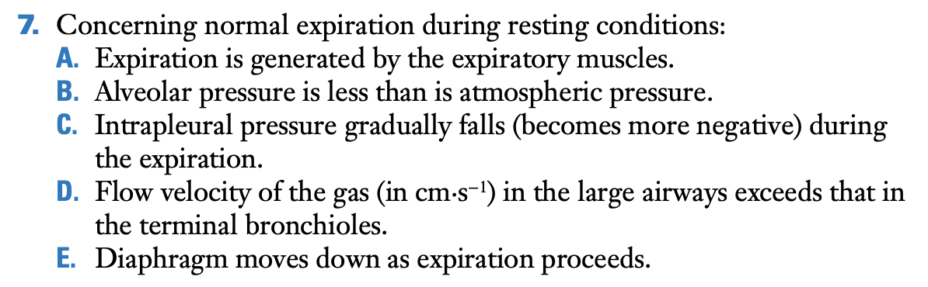

D is correct. The velocity of the gas in the large airways exceeds that in the terminal bronchioles because the latter have a very large combined cross-sectional area (see Figure 1.5). The other choices are incorrect. Under resting conditions, expiration is passive, it is associated with an alveolar pressure that exceeds atmospheric pressure, intrapleural pressure gradually increases (becomes less negative) during expiration, and the diaphragm moves up as expiration proceeds.

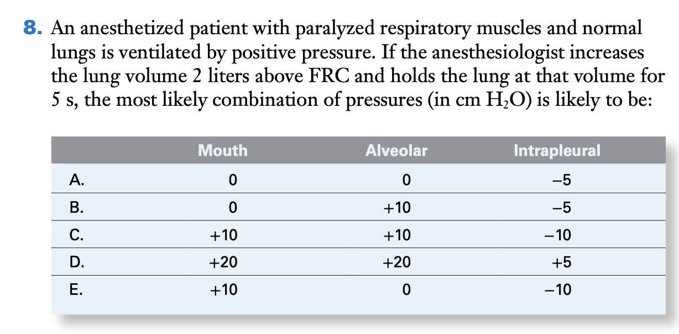

D is correct. If the lung is held at a given volume, mouth and alveolar pressure must be the same because there is no airflow. Therefore, the answer is either C or D. Because the lung was expanded with positive pressure, all the pressures inside the thorax increase. Since the normal intrapleural pressure is about −5 cm H2O, it cannot fall to −10 as shown in C. Therefore, the only possible answer is D.

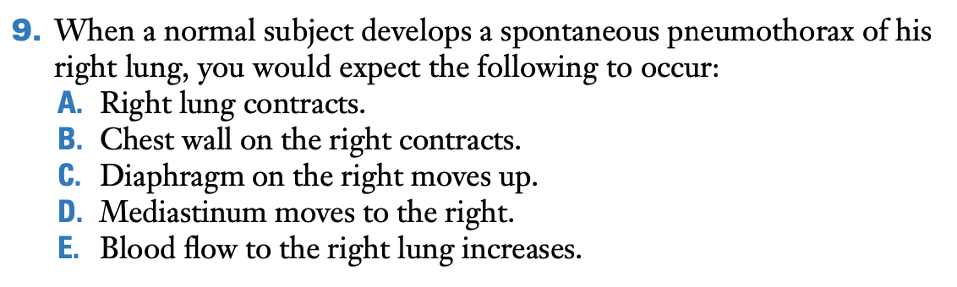

A is the correct answer. Spontaneous pneumothorax of the right lung will decrease its volume because the normal expanding pressure is abolished. All the other choices are incorrect. The increase in pressure on the right will cause the chest wall on that side to expand, the diaphragm to move down, and the mediastinum to shift to the left. The blood flow to the right lung will be reduced both because its volume is small and because there is hypoxic pulmonary vasoconstriction.

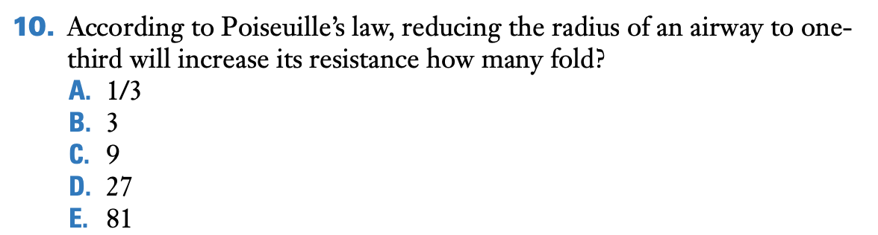

E.

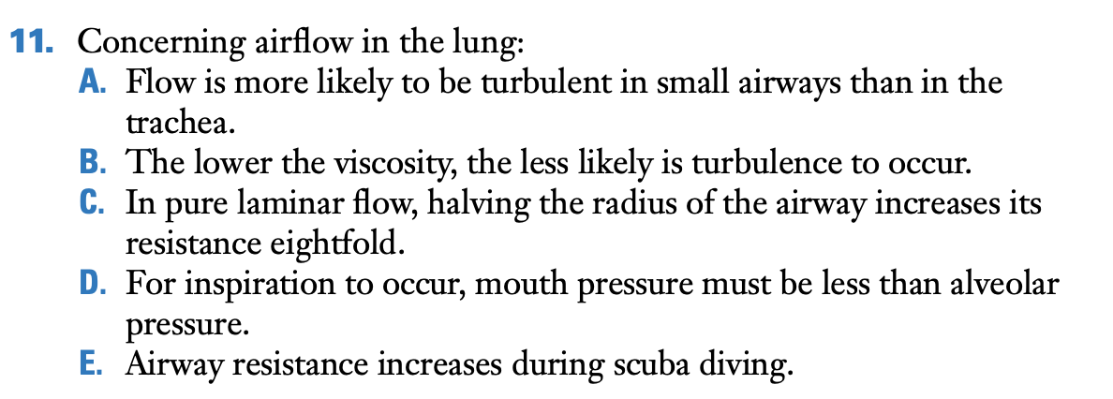

E is correct. During scuba diving, the density of the air is increased because of the raised pressure, and therefore, airway resistance rises. The other choices are incorrect. Flow is most likely to be turbulent in large airways; the higher the viscosity, the less likely is turbulence to occur; halving the radius of the airway increases its resistance 16-fold; and during inspiration, alveolar pressure must be less than mouth pressure.

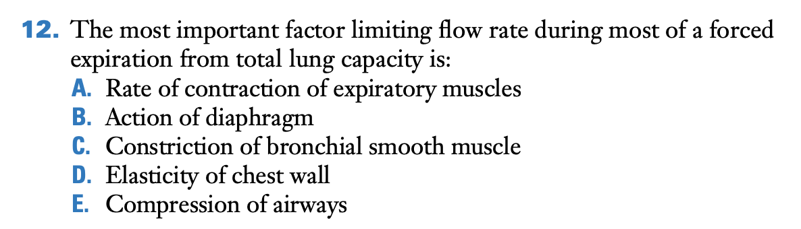

E is correct. During most of a forced expiration from TLC, dynamic compression of the airways limits flow (Figures 7.16 to 7.18). All the other choices are incorrect. In particular, flow is independent of effort.

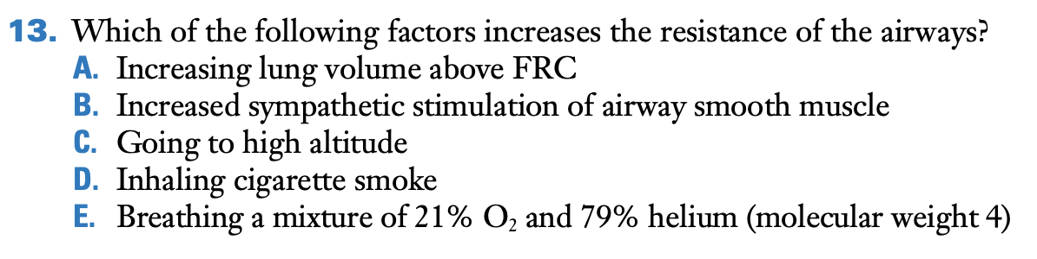

D is correct. Inhalation of cigarette smoke causes reflex constriction of airway smooth muscle as a result of stimulation of irritant receptors in the airway wall (see Chapter 8). The other choices are incorrect. Both increasing lung volume above FRC and sympathetic stimulation of airway smooth muscle reduce airway resistance. Going to high altitude does the same because the density of the air is reduced. The density is also decreased when nitrogen is replaced by helium in the inspired gas.

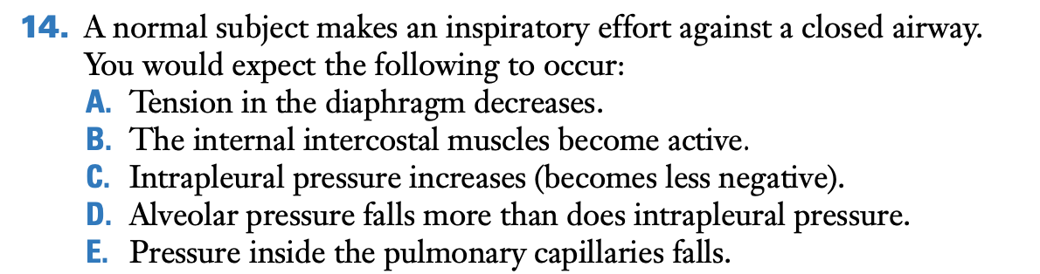

E is correct. When an inspiratory effort is made against a closed airway, all the pressures inside the thorax fall including the pulmonary vascular pressures. The other choices are incorrect. During inspiration, the tension in the diaphragm increases, external and not internal intercostal muscles become active, intrapleural pressure becomes more negative, and alveolar pressure will fall equally with intrapleural pressure if lung volume does not change. If lung volume does increase slightly, intrapleural pressure will fall more than will alveolar pressure.

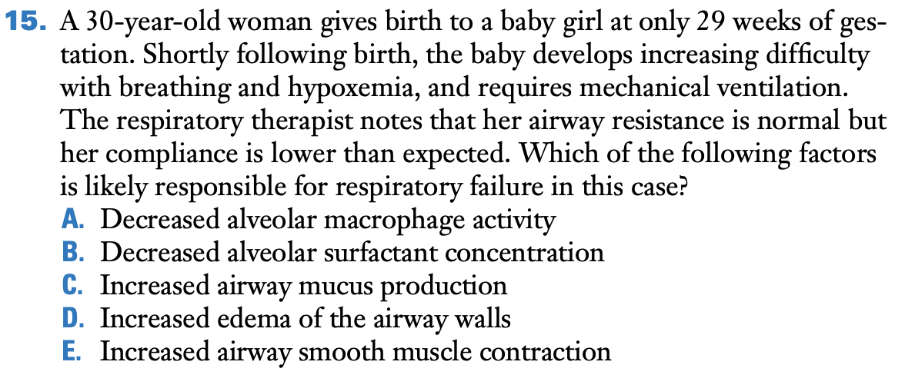

B is correct. Infants born prematurely sometimes lack surfactant, which is necessary to overcome alveolar surface tension and prevent atelectasis. This puts them at risk for infant respiratory distress syndrome, which is associated with decreased compliance. Increased airway mucus production and smooth muscle contraction and increased edema of the airway wall are all associated with increased airway resistance. Decreased alveolar macrophage concentrations might affect susceptibility to infection but would not affect compliance.

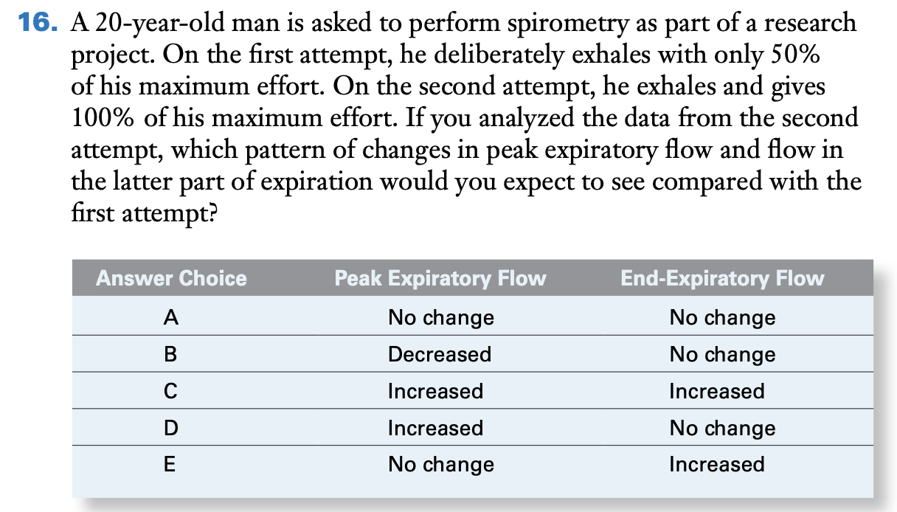

D is correct. During forced expiration tests, increased effort causes an increase in peak expiratory flow but has no effect on flow toward the end of exhalation (see Figure 7.16). This period of effort-independent flow is due to dynamic compression of the airways during forced exhalation. The other answer choices do not fit this pattern and are incorrect.

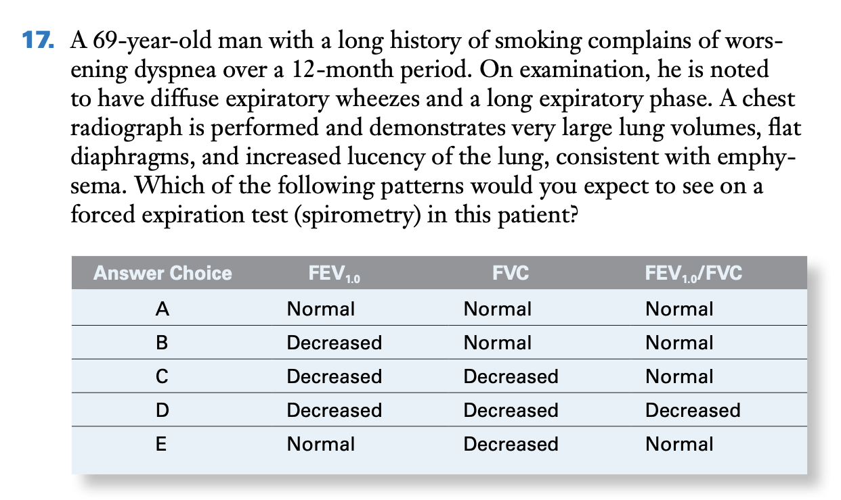

D is correct. The clinical features of this case, including the long smoking history, wheezes and prolonged exhalation on exam, and a chest radiograph with large lung volumes and increased lucency of the lung are all suggestive of obstructive lung disease. A diagnostic hallmark is a low FEV1.0/FVC ratio. FEV1.0 is typically reduced as is FVC. None of the other choices have a low FEV1.0/FVC ratio and, therefore, they are all incorrect.

# CHAPTER 8 – CONTROL OF VENTILATION: how gas exchange is regulated

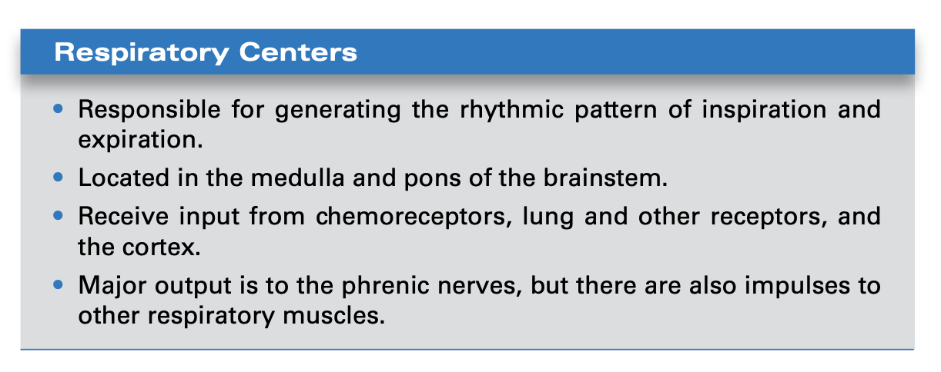

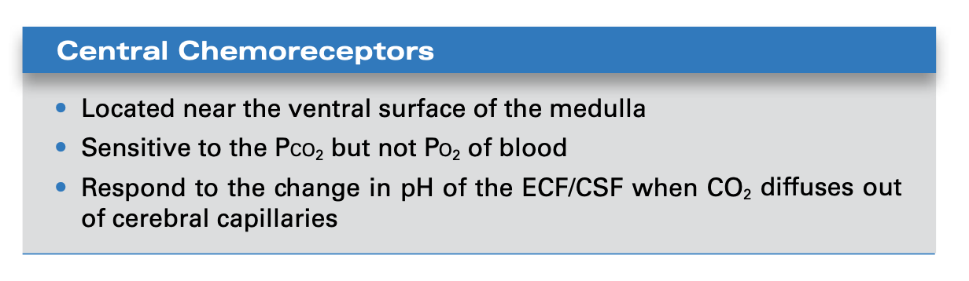

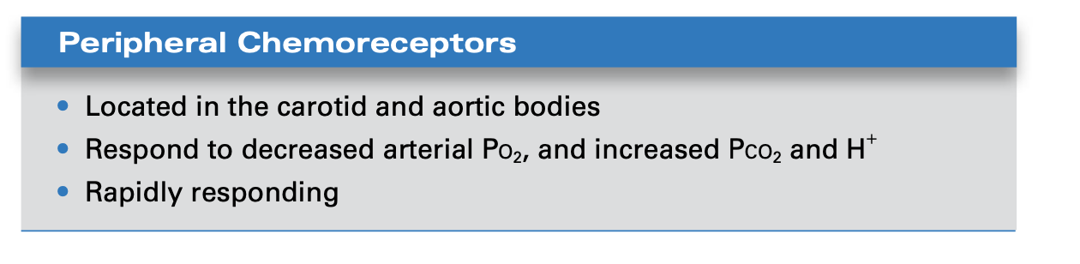

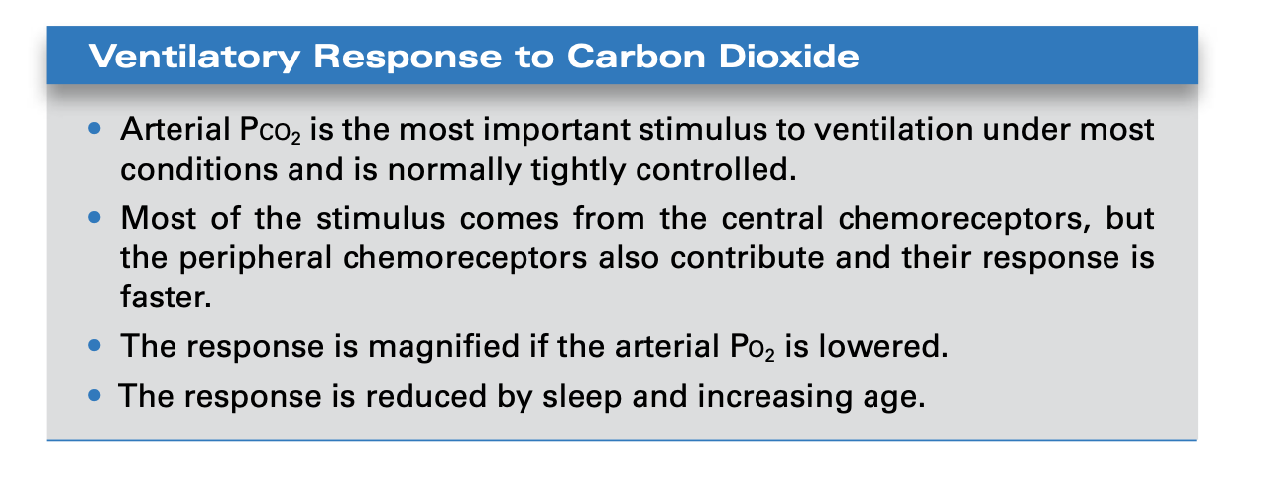

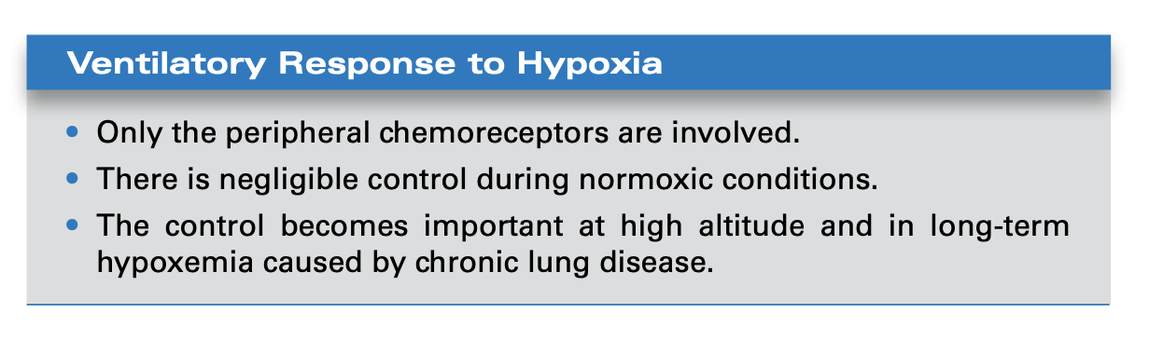

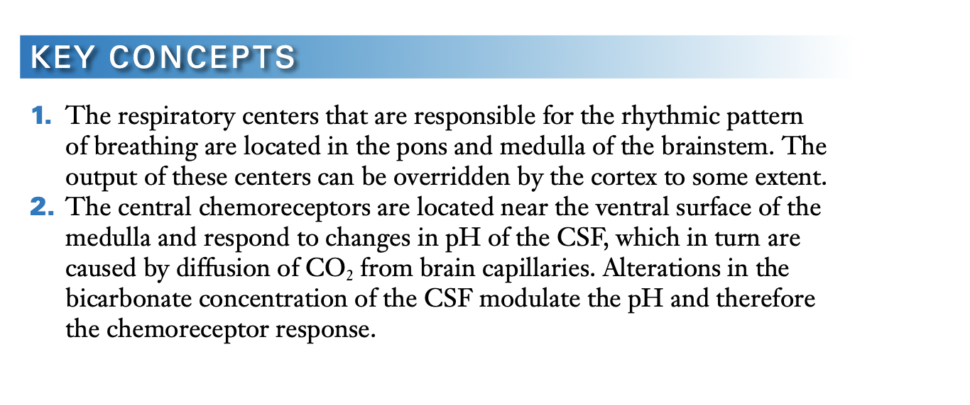

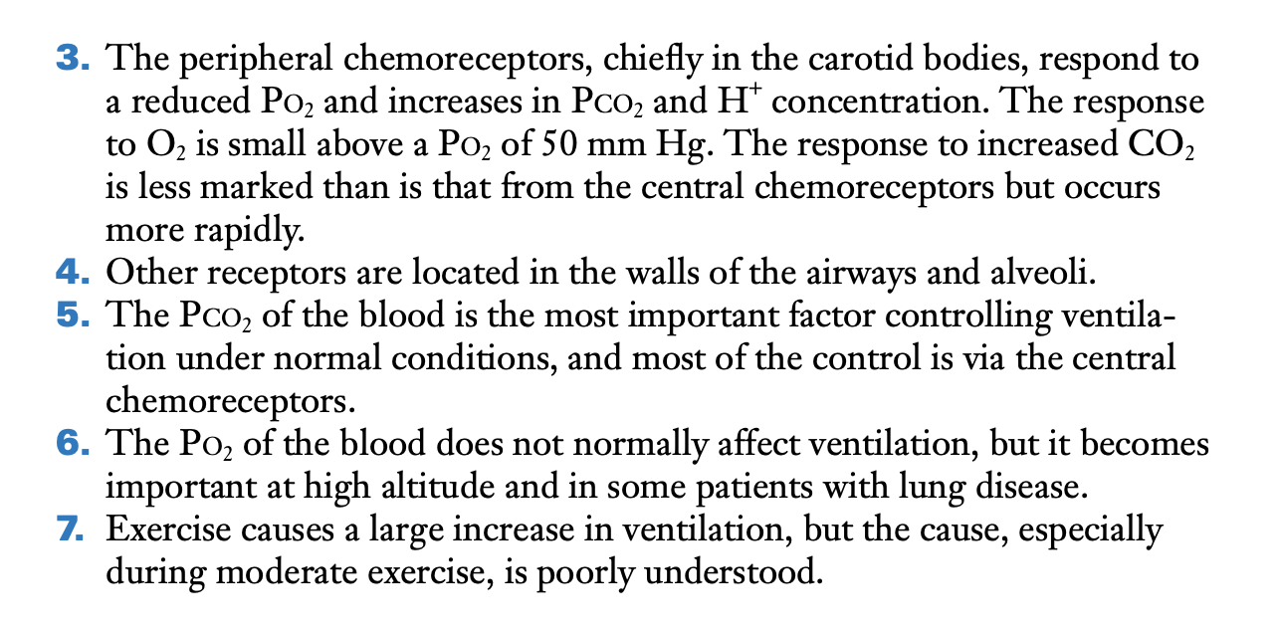

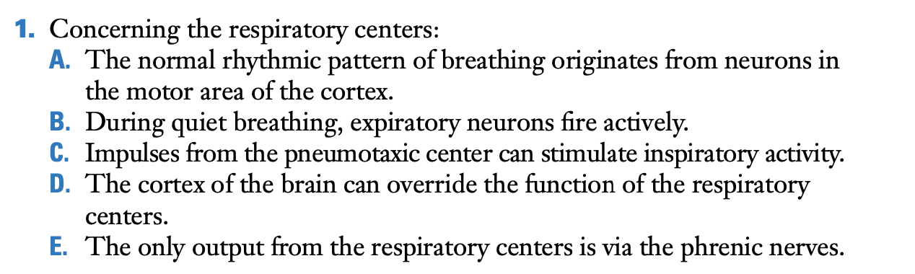

D.

The cortex can override the function of the respiratory centers, for example, during voluntary hyperventilation, or voluntary breath-holding. The other choices are incorrect. The normal rhythmic pattern of breathing originates in the brainstem, not the cortex. Expiration is passive during quiet breathing, impulses from the pneumotaxic center inhibit inspiration, and the output from the respiratory centers includes impulses from the spinal cord to the intercostal and other muscles in addition to the phrenic nerves.

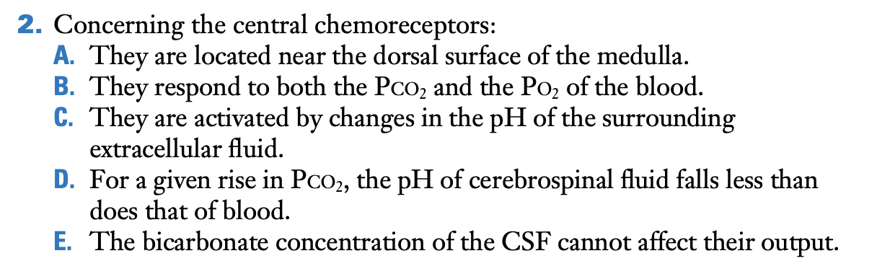

C.

The central chemoreceptors are located near the ventral surface of the medulla; they do not respond to the PO2 of blood; for a given rise in PCO2, the CSF pH falls more than that of blood because the CSF has less buffering; and the bicarbonate concentration of the CSF can affect the output of the central chemoreceptors by buffering the changes in pH.

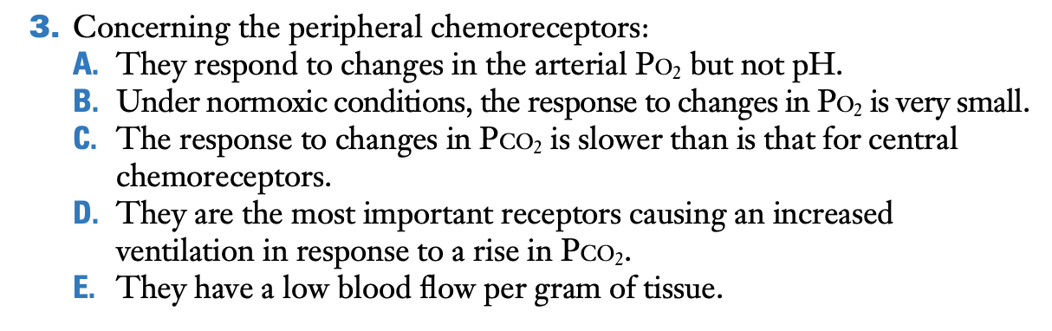

B.

The peripheral chemoreceptors are responsive to the arterial PO2, but during normoxia, the response is small.

Peripheral chemoreceptors do respond to changes in blood pH, the response to changes in PCO2 is faster than is the case for central chemoreceptors, the central chemoreceptors are more important than are the peripheral chemoreceptors in the ventilatory response to increased CO2, and peripheral chemoreceptors have a very high blood flow in relation to their mass.

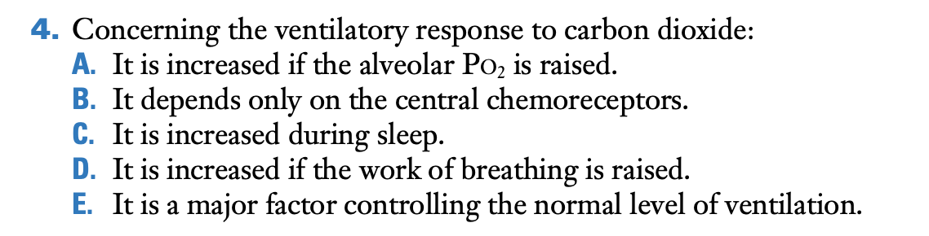

E.

The normal level of ventilation is controlled by the ventilatory response to CO2. The other choices are incorrect. The ventilatory response to CO2 is increased if the alveolar PO2 is reduced, the ventilatory response depends on the peripheral chemoreceptors in addition to the central chemoreceptors, and the ventilatory response is reduced during sleep and if the work of breathing is increased**.**

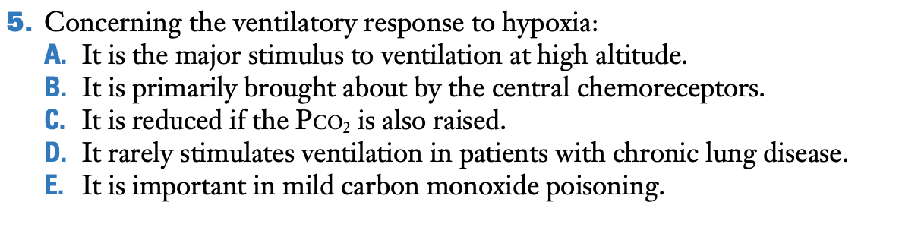

A.

Ventilation increases greatly at high altitude in response to hypoxic stimulation of chemoreceptors. The other choices are incorrect. It is the peripheral chemoreceptors, not the central chemoreceptors that are responsible for the response. The response is increased if the PCO2 is also raised. Hypoxic stimulation is often important in patients with long-standing severe lung disease who have nearly normal values for the pH of the CSF and blood. Mild carbon monoxide poisoning is associated with a normal arterial PO2, and therefore, there is no stimulation of the peripheral chemoreceptors.

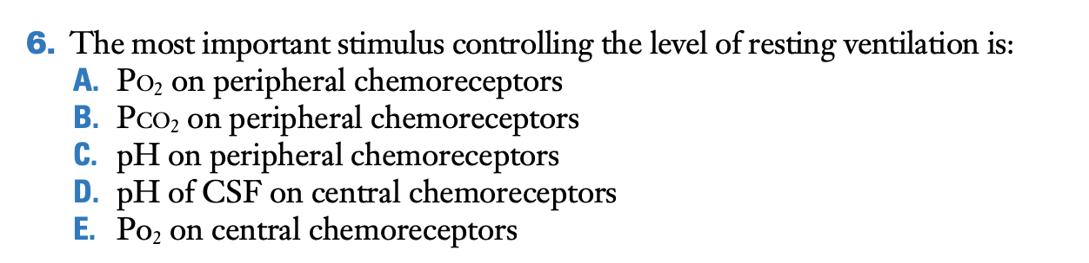

D.

As Figure 8.2 shows, the most important stimulus comes from the pH of the CSF on the central chemoreceptors. The other choices are incorrect. The effect of PO2 on the peripheral chemoreceptors under normoxic conditions is very small. Changes in PCO2 do affect the peripheral chemoreceptors, but the magnitude is less than is that for the central chemoreceptors. The effect of changes in pH on peripheral chemoreceptors under normal conditions is small, and changes in PO2 do not affect the central chemoreceptors.

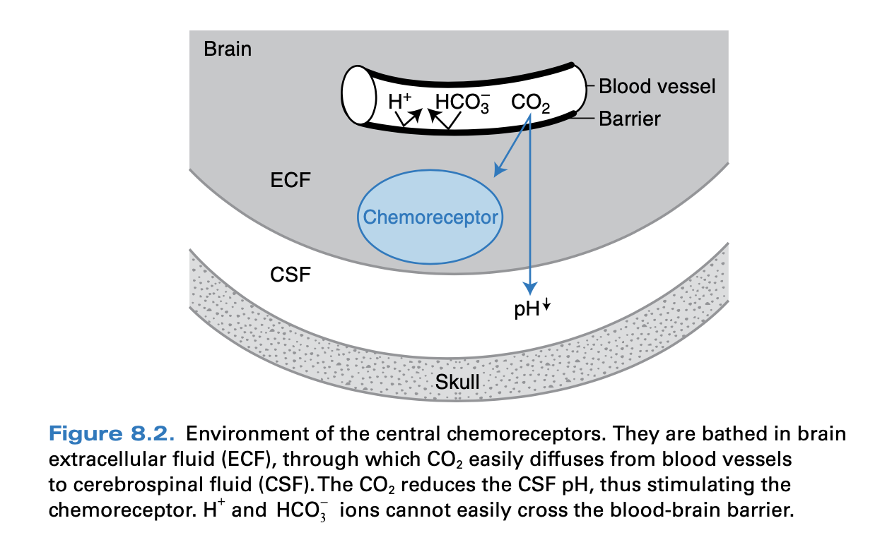

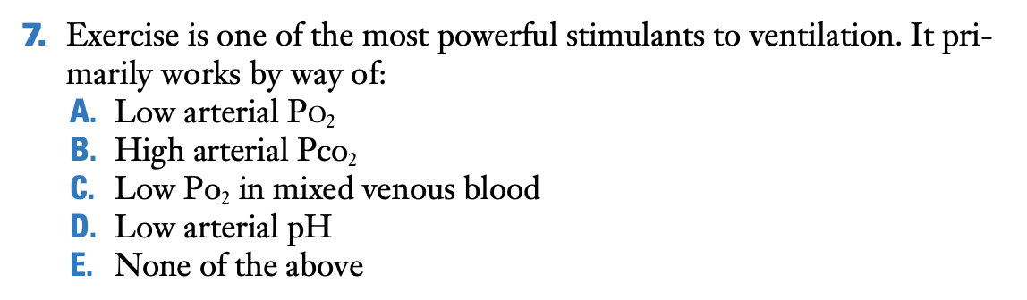

E.

Moderate exercise does not reduce the arterial PO2, increase the arterial PCO2, or reduce the arterial pH. The PO2 of mixed venous blood does fall, but there are no known chemoreceptors that are stimulated as a result.

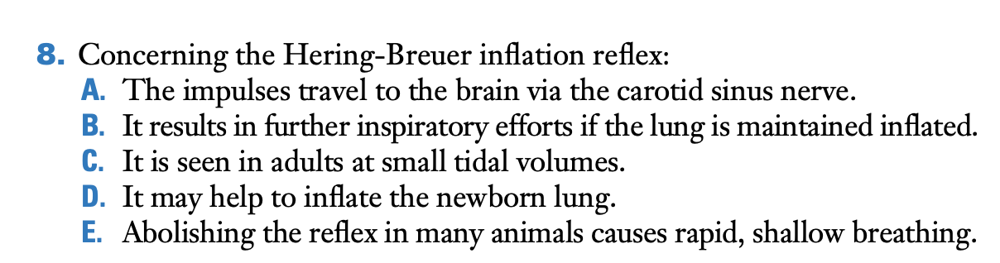

D.

The other choices are incorrect. The impulses travel to the brain via the vagus nerve, the reflex inhibits further inspiratory efforts if the lung is maintained inflated, the reflex is not seen in adults at small tidal volumes, and abolishing the reflex by cutting the vagal nerves in experimental animals causes slow deep breathing.

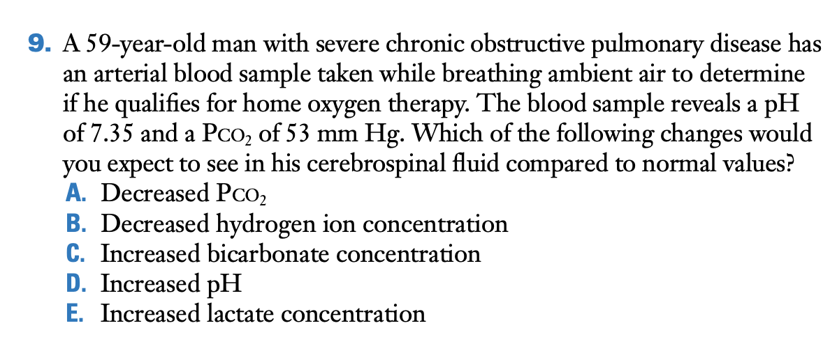

C.

When the blood PCO2 rises, CO2 diffuses into the CSF. This increases CSF PCO2, leading to liberation of hydrogen ions and a decreased pH. If the CSF pH is displaced for a long period of time, as in a patient with chronic hypercarbia due to severe COPD, CSF bicarbonate concentration increases as a compensatory response. The pH will increase but will not usually return all the way to a normal CSF pH of 7.32.

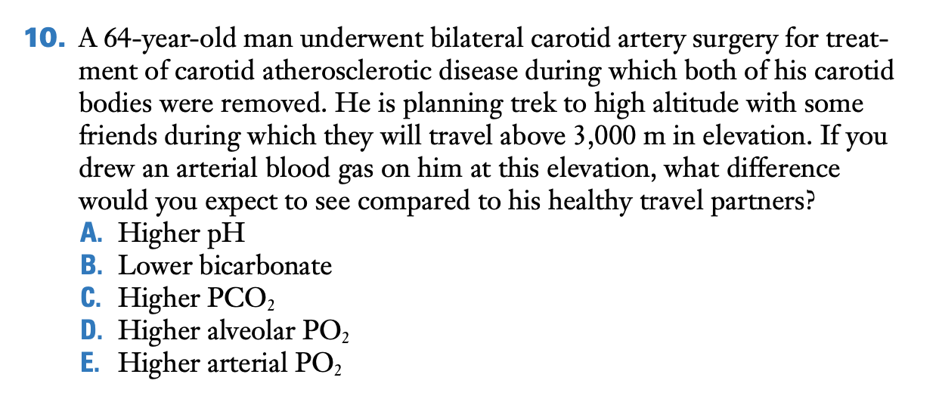

C.

The most important peripheral chemoreceptors that mediate the hypoxic ventilatory response are located in the carotid bodies. Following bilateral carotid body resection, the patient would not experience the same increase in minute and alveolar ventilation following ascent to high altitude as individuals with intact carotid bodies and would have a higher arterial PCO2. With less increase in minute ventilation than a normal individual, the alveolar and arterial PO2 would be lower. The pH would also be lower because of the higher PCO2.

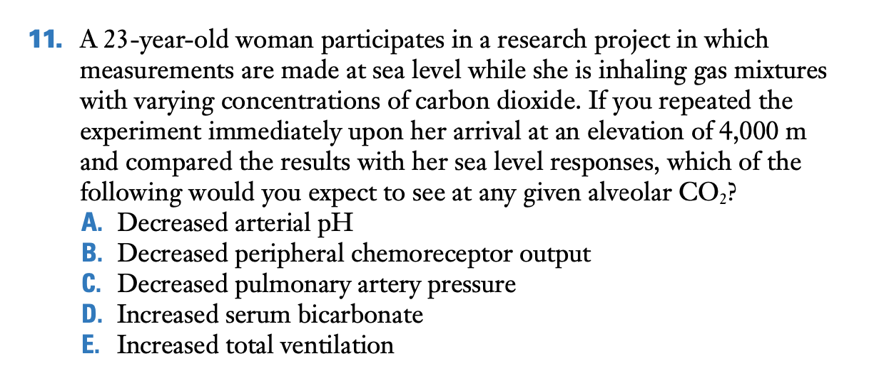

E.

Ventilation increases in response to increases in arterial PCO2. When arterial PO2 decreases, as would occur following ascent to high altitude, ventilation for a given PCO2 is higher than in normoxia and the slope of the ventilatory response curve is steeper. The other choices are incorrect. Alveolar hypoxia would trigger hypoxic pulmonary vasoconstriction and increase pulmonary artery pressure, while hypoxemia increases peripheral chemoreceptor output. The decrease in PCO2 that results from the increase in total ventilation will lead to a decrease in serum bicarbonate and an increase in pH.

# Respiratory Gas Transport

Each **hemoglobin** molecule is a protein made up of four subunits bound together. Each subunit consists of a molecular group known as **heme** and a polypeptide attached to the heme. The four polypeptides of a hemoglobin molecule are collectively called **globin.**

Therefore, hemoglobin can exist in one of two forms— **deoxyhemoglobin** (**Hb**) and **oxyhemoglobin** (**HbO2**). In a blood sample containing many hemoglobin molecules, the fraction of all the hemoglobin in the form of oxyhemoglobin is expressed as the **percent hemoglobin saturation.**

Another 25% to 30% of the carbon dioxide molecules entering the blood react reversibly with the amino groups of hemoglobin to form **carbaminohemoglobin.**

The remaining 60% to 65% of the carbon dioxide molecules entering the blood in the tissues is converted to HCO3-.

Recall that the PO2 of arterial blood is determined primarily by the oxygen-diffusion capacity of the lung, whereas the total amount of oxygen in the blood is also dependent on the amount of hemoglobin there to carry the oxygen. Therefore, mild to moderate anemia, in which arterial PO2 is usually normal, does not activate peripheral chemo- receptors and does not stimulate increased ventilation.

# VSL[14] Questions

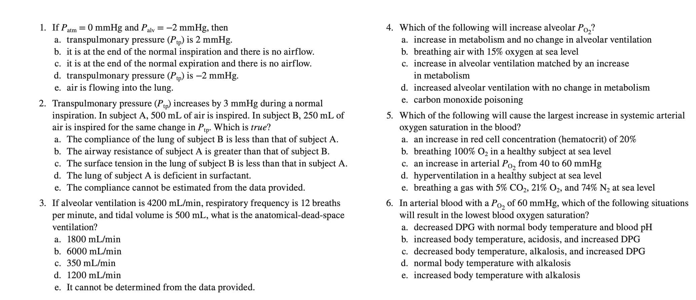

1. e
2. a
3. a
4. d. An increase in alveolar *P*O2 results from an increase in alveolar ventilation (supply of oxygen) relative to metabolic rate (consumption of oxygen).
5. c. The relationship between arterial *P*O2 and arterial oxygen saturation is described by the oxygen–hemoglobin dissociation curve. The greatest increase in oxygen saturation for the same change in *P*O2 occurs at the steepest part of the curve—a *P*O2 of between 40 and 60 mmHg.
6. b. Increases in blood temperature, decreases in blood pH,  
   and increases in DPG shift the oxygen–hemoglobin curve downward, leading to a lower oxygen saturation at the same *P*O2

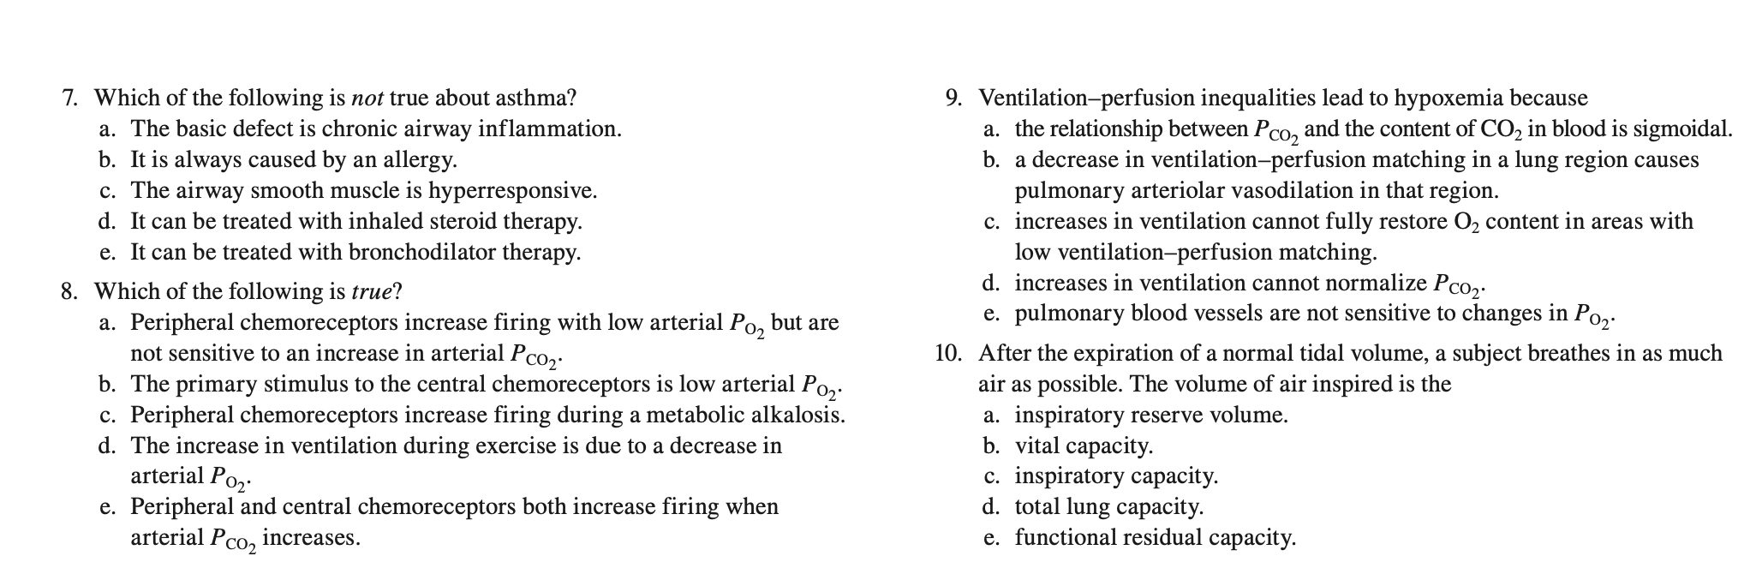

7.b

8.e. Respiratory acidosis (increase in blood *P*CO2 and decrease in pH) is a major stimulus to ventilation—this is mediated both by afferents from the peripheral chemoreceptors and by an increase in central chemoreceptor activity.

9.c. Because of the shape of the oxygen–hemoglobin dissociation curve, small increases in *P*O2 due to increases in ventilation cannot fully saturate hemoglobin. When the desaturated blood mixes with saturated blood, the average is still hypoxemic.

10.c

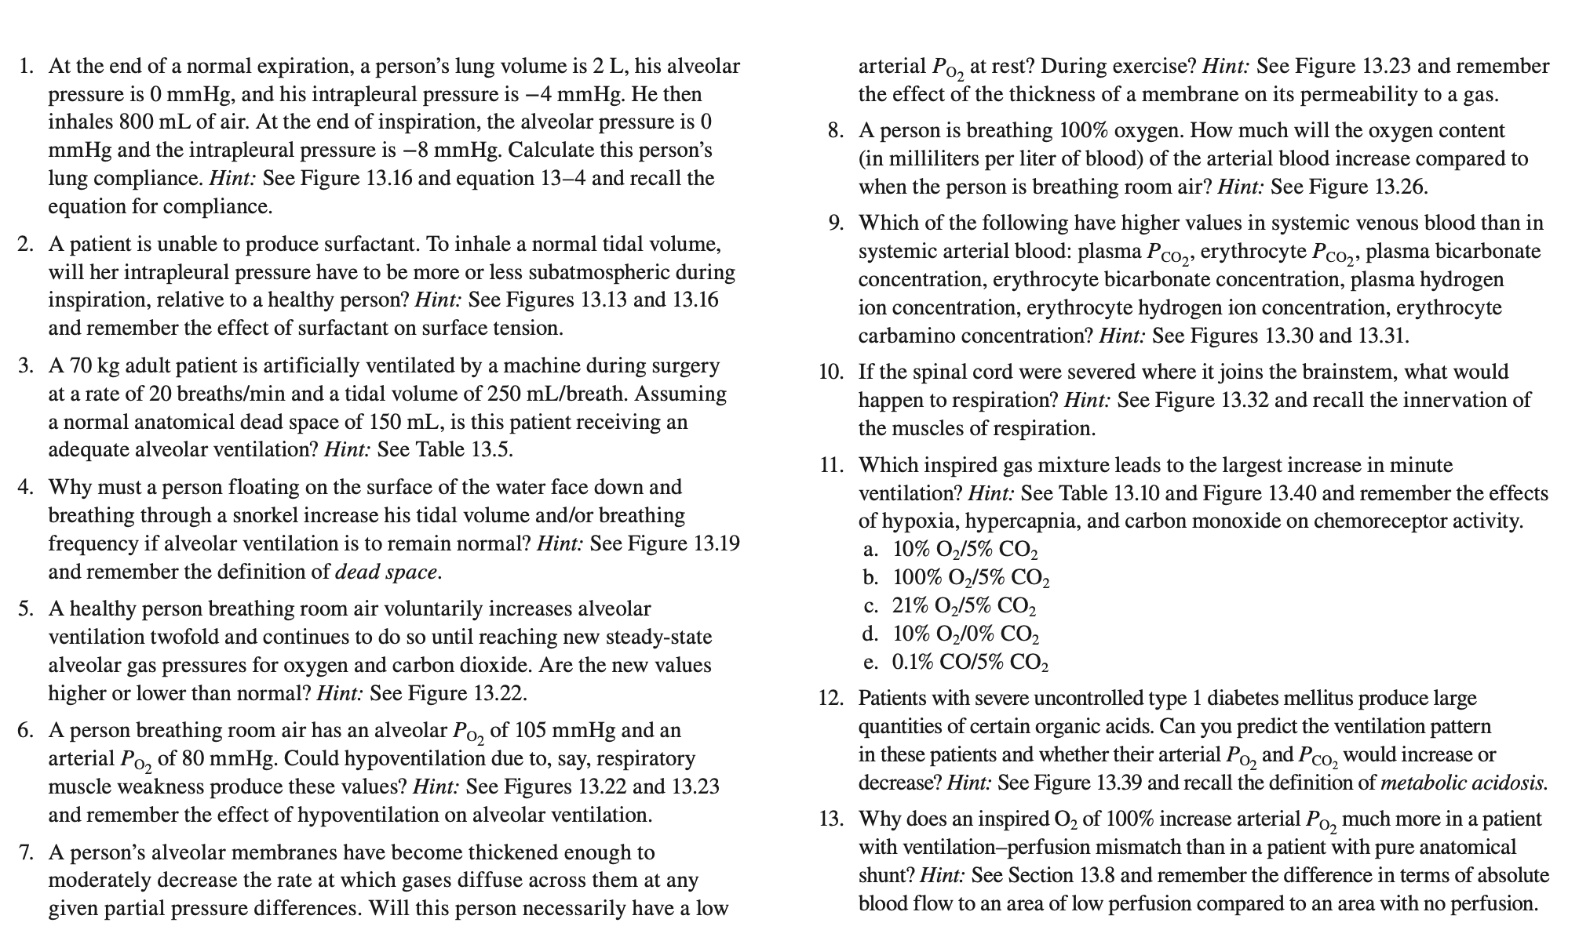

1. 0.20
2. More subatmospheric Palv – Pip
3. No. Breathing rapidly and shallowly, 2000 ml/min
4. The volume of the snorkel constitutes an additional dead space, so total pulmonary ventilation must be increased if alveolar ventilation is to remain constant. The most efficient way to do this is to increase tidal volume.
5. The alveolar *P*O2 will be higher than normal, and the alveolar *P*CO2 will be lower. To better understand why, review the factors that determine the alveolar gas pressures (see Table 13.6).
6. No. Hypoventilation reduces arterial *P*O2 but only because it reduces alveolar *P*O2 That is, in hypoventilation, *both* alveolar and arterial *P*O2 are decreased to essentially the same degree. In this problem, alveolar *P*O2 is normal, and so the person is not hypoventilating. The low arterial *P*O2 must therefore represent a defect that causes a discrepancy between alveolar *P*O2 and arterial *P*O2. Possibilities include impaired diffusion, a shunting of blood from the right side of the heart to the left through a hole in the heart wall, and a mismatch between airflow and blood flow in the alveoli.
7. Not at rest, if the defect is not too severe. Recall that equilibration of alveolar air and pulmonary capillary blood is normally so rapid that it occurs well before the end of the capillaries. Therefore, even though diffusion may be slowed as in this problem, there may still be enough time for equilibration to be reached. In contrast, the time for equilibration is decreased during exercise (because of an increase in the rate of blood flow through the pulmonary circulation), and failure to equilibrate is much more likely to occur, resulting in a lowered arterial *P*O2.

8. Only a few percent (specifically, from approximately 200 mL O2/L blood to approximately 215 mL O2/L blood). The reason the increase is so small is that almost all the oxygen in blood is carried bound to hemoglobin, and hemoglobin is almost 100% saturated at the arterial *P*O2 achieved by breathing room air. The high arterial *P*O2 achieved by breathing 100% oxygen does cause a directly proportional increase in the amount of oxygen *dissolved* in the blood (the additional 15 mL), but this still remains a small fraction of the total oxygen in the blood. Review the numbers given in the chapter.

9. All. Venous blood contains products of metabolism released by cells, such as carbon dioxide.

10. It would cease. Respiration depends on descending input from the medulla to the nerves supplying the diaphragm and the inspiratory intercostal muscles.

11. a. The combination of hypercapnia (increased *P*CO2 due to increased inspired CO2) and hypoxia (due to decreased inspired O2) greatly augments ventilation by stimulating central and peripheral chemoreceptors. Although CO decreases O2 content, chemoreceptors are not stimulated and ventilation does not increase.

12. These patients have profound hyperventilation, with large increases in both the depth and rate of ventilation. The stimulus, mainly via the peripheral chemoreceptors, is the large increase in their arterial hydrogen ion concentration due to the acids produced. The hyperventilation causes an increase in their arterial *P*O2 and a decrease in their arterial *P*CO2

13. An important feature of an anatomical shunt is that if an affected individual is given 100% O2 to breathe, the response is blunted severely. The blood that bypasses the gas-exchanging units is never exposed to the enriched O2, and thus it continues to be deoxygenated. The PO2 in the blood that is not being shunted increases and it mixes with the deoxygenated blood. Thus the degree of persistent hypoxemia in response to 100% O2 varies with the volume of the shunted blood.

# Terminology

**Hypoxia** is a condition in which the body or a region of the body is deprived of adequate oxygen supply at the tissue level. Hypoxia may be classified as either generalized, affecting the whole body, or local, affecting a region of the body.

**Hypoxemia** is a below-normal level of oxygen in your blood, specifically in the arteries. Hypoxemia is a sign of a problem related to breathing or circulation, and may result in various symptoms, such as shortness of breath.

**Hypercapnia**: excessive carbon dioxide in the bloodstream, typically caused by inadequate respiration.

Acidosis: ↓pH alkalosis: ↑pH

# Difference between Bohr And Haldane Effect

<https://pediaa.com/what-is-the-difference-between-bohr-and-haldane-effect/>

Bohr effect

Caused by CO2 which reduces the affinity of Hgb for O2,

The Bohr Effect refers to the observation that increases in the carbon dioxide partial pressure of blood or decreases in blood pH result in a lower affinity of hemoglobin for oxygen. This manifests as a right-shift in the oxygen-hemoglobin saturation curve and yields enhanced unloading of oxygen by hemoglobin. This takes place at the tissue capillaries because of the elevated temperature pCO2, and acidity of metabolizing tissues.

Since carbon dioxide reacts with water to form carbonic acid H2CO3, an increase in CO2 results in a decrease in blood pH resulting in hemoglobin proteins releasing their load of oxygen. Conversely, a decrease in carbon dioxide provokes an increase in pH, which results in hemoglobin picking up more oxygen.

The O2 dissociation curve is shifted to the right, that is, the O2 affinity of Hb is reduced, by an increase in H+ concentration, PCO2, temperature, and the concentration of 2,3-diphosphoglycerate (DPG), or decrease in pH in the red cells. This takes place in

Haldane effect

Describes that the increase in PO2 that takes place in pulmonary capillaries favors off-loading of CO2 from hemoglobin. The binding of oxygen to hemoglobin promotes the release of carbon dioxide.

The Haldane Effect is likely the result of two effects of oxygen binding on hemoglobin. First, binding of oxygen to hemoglobin appears to directly reduce the affinity of the protein for carbon dioxide in the form of carbaminohemoglobin.

Secondly, binding of oxygen to hemoglobin facilitates conversion of bicarbonate to carbon dioxide in the pulmonary circulation and in turn enhances carbon dioxide elimination.

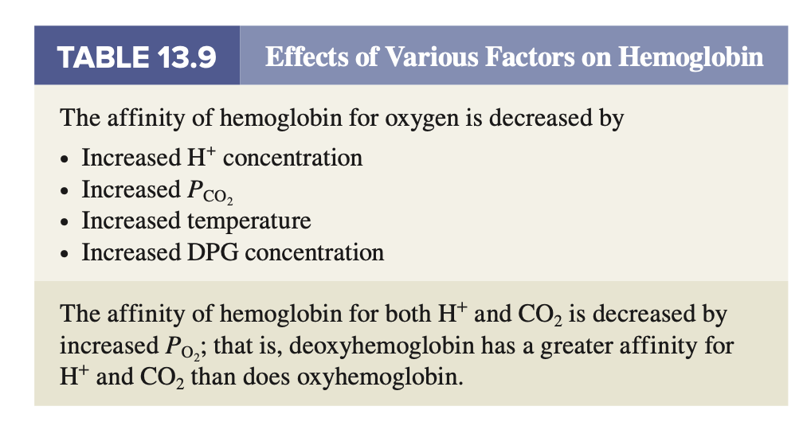

VSL[14]